Parallelism

* **CPU:** central processing unit
* **GPU:** graphical processing units (well-suited for data parallel programs, not for programs with random accesses)
* **Parallelism:** *use extra rescources to solve problem faster* → requires coordination
* **Concurrency:** *correctly and efficiently manage access to shared resources* 🡪 requires synchronization
* **Class:** a program entity that represents either a program or a type of objects
* **Object**: an entity that combines data and behavior
* **Variable:** piece of computer’s memory that is given a name and type and can store a value
* **Assign statement:** a Java statement that stores a value into a variable’s memory location
* A **method** is a collection of statements that are grouped together to perform an operation
* **returnValueType** is the data type of the value the method returns. If the method doesn’t return a value, the type is void
* **interface:** a list of methods that a class can implement

# Introduction to Java

## Java Grundkurs

**Primitive types:** byte, short, **int**, long, float, **double, boolean, char**

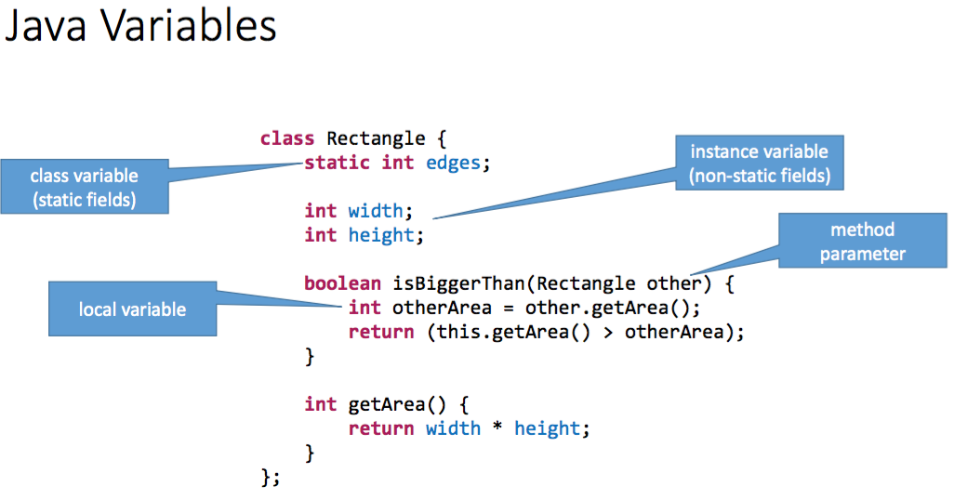 GET/SET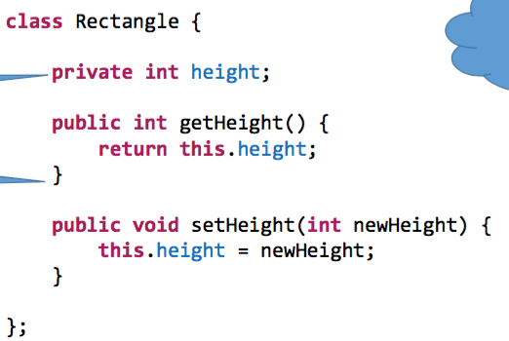

**Constructing an objet and calling an object’s method:**

Type objectName = new Type(parameters);

objectName.methodName(parameters);

**import**

at beginning of file, before class name! E.g.

import java.util.ArrayList; import java.util.concurrent.locks.ReentrantLock

**Random**

Import java.util.Random

Random rnd = new Random(seed); //random object

Int randomInt = rnd.nextInt(); //random integer (same with Double)

**Arrays**

Datentyp[] name = new datentyp[length] // Length = Grösse des Arrays

Int[] testInts = new int[2]; // Array mit Datentyp Int & Länge 2

testInts[0] = 27; // 1. Stelle des Arrays steht 27

String[] testStrings = new String[6]; // Array mit Datentyp String & Länge 6

**Listen**

List<String> stringlist = new ArrayList<String>(); // Definition einer String Liste

List<Integer> intList = new ArrayList<Integer>(); // Definition einer Integer Liste

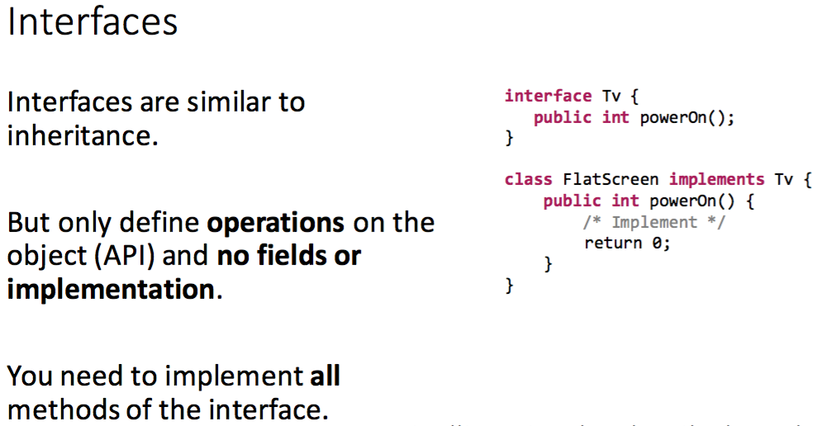

## Mögliche Fehlerquellen

**Verwendung von „static“ bei der Definition von Variabeln**

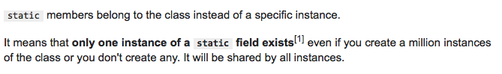

**Vererbung -> Aufpassen bei Objektinstanzierung**

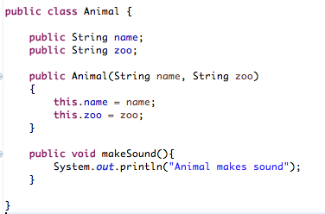 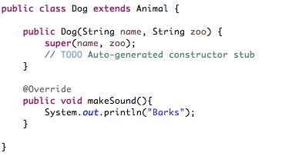

**Instanzierung-Beispiele**

Animal Giraffe = new Animal(„Fritz“, „Züri Zoo“); // Korrekte Objekt Instanziierung

Dog Bernadiner = new Dog(„Leo“, Züri Zoo“); // Korrekte Objekt Instanziierung

Animal Husky = new Dog(„Max“, „Streichelzoo“); // Korrekte Objekt Instanziierung

**Dog Pudel = new Anmial(„Hanna“, „Streichelzoo“);**

// FEHLER 🡪 Ein „Animal“ kann nicht in einen „Dog“ konvertiert werden, da ein „Dog“ die Verfeinerung der Klasse „Animal“ ist 🡪 Für die Klasse „Dog“ könnten bsp. noch weitere Attribute definiert werden, welche dann mit diesem Aufruf fehlen würden

**Typen**

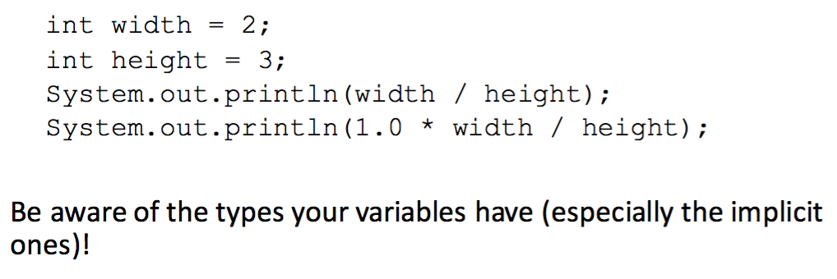

**Stringvergleiche**

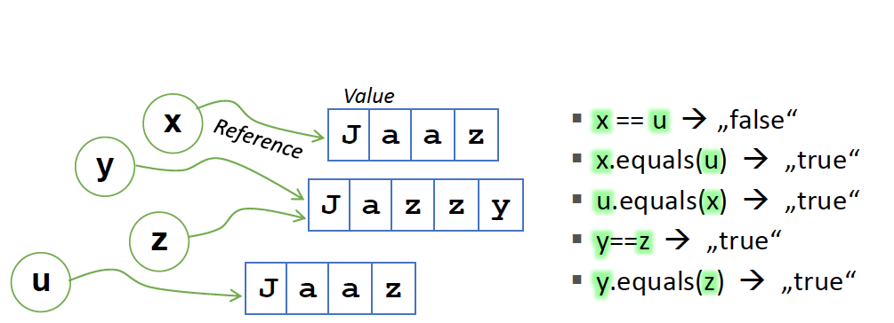 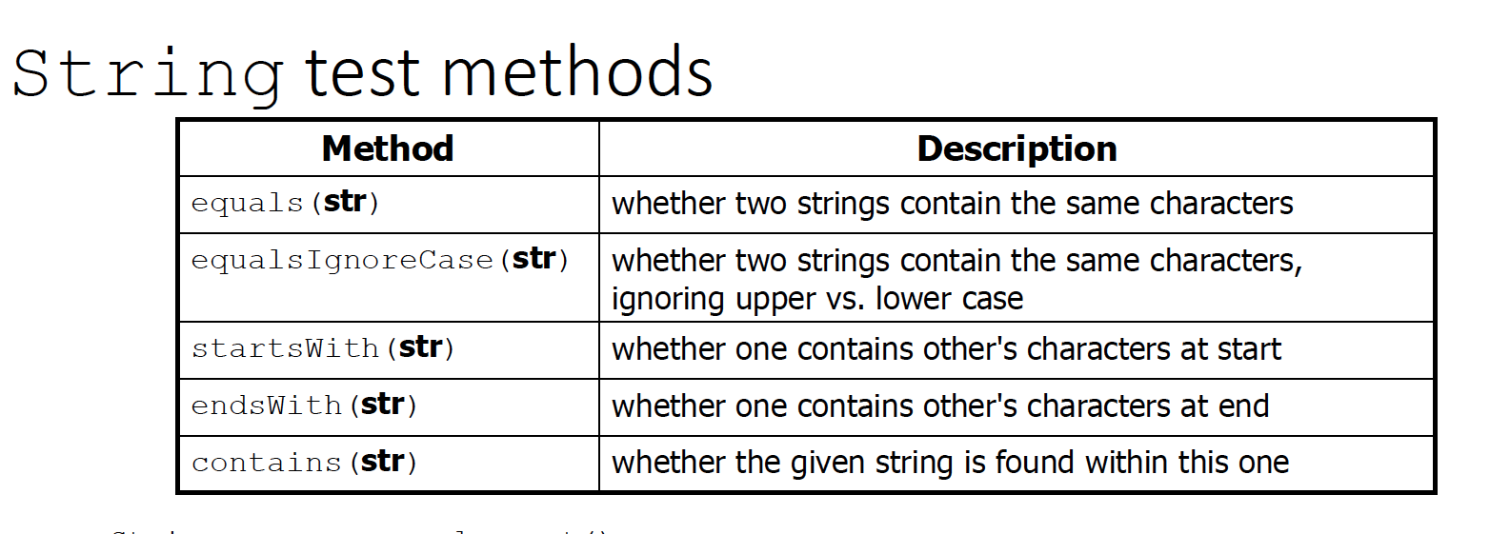

🡪 Immer Objekt equals(string) oder Objekt.equals(Objekt2) verwenden

🡪 Bei Objekt == Objekt2 wird der Inhalt der Zeichenkette nicht verglichen!

**Parallel Loops:**

**Parfor** (i = 2; i<n; i++) {

Factorial[i] = i*factorial[i-1]

//be careful with how index arrays 🡪 accesses and writes in same array at different places 🡪 errorous!

}

## Exception Handling

many different error types: syntax, logic, arithmetic, runtime, … 🡪 every method must state the types of checked exceptions it might throw:

pubic void myMethod()

throws IllegalArgumentException, NullPointerException {

…

throw new IllegalArgumentException(…)

}

or

try { statements; }

catch (TheException ex) { handling ex; }

finally { finallyStatements; }

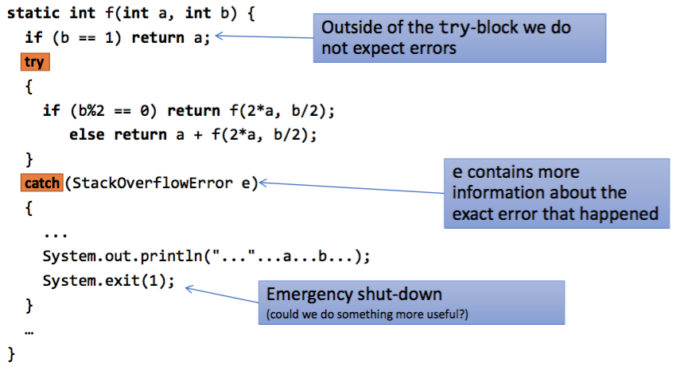

# Parallel Architectures

**Moore’s law:** number of transistors on integrated circuits doubles approx. every two years (more transistors 🡪 more performance)

→ sequential programs became exponentially faster with each new CPU → no longer affordable (expensive to cool) → multicore processors → parallel programs to take advantage

**von Neumann architecture:** program data and program instructions in the same memory

**multicore processors**

🡪 Use transistors to add cores (instead of improving sequential performance)

🡪 Expose parallelism to software

🡪 Implication: programmers need to write parallel programs to take advantage of new hardware

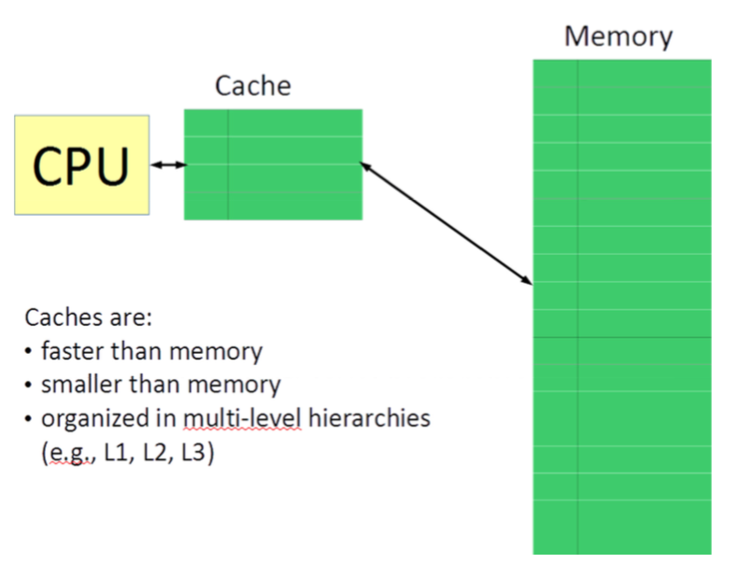

**Cache (Hit, Miss):** Hit falls Daten gefunden im Cache, sonst miss // CPU → Cache → Memory

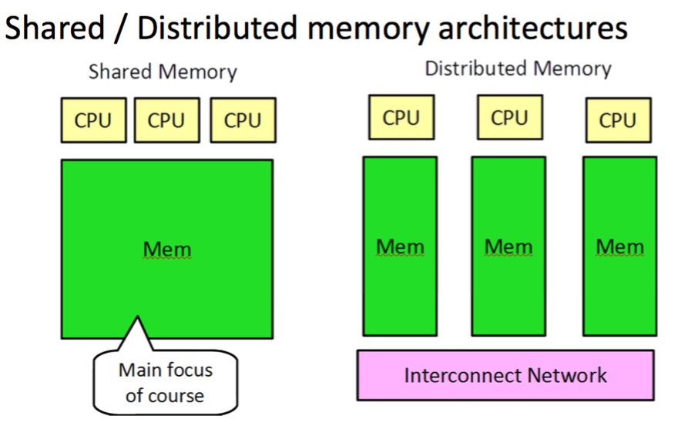

## Shared memory architectures

Same programming interface, different implementation → different performance characteristics:

**Simultaneous Multithreading (SMT)**

* single core, multiple instruction streams (threads)   
  🡪 2 execution threads on a single execution unit
* Between ILP ↔ multicore (ILP: multiple units for (one) instr. Stream, SMT: multiple units for multiple instr. Streams)
* Limited parallel performance

🡪 cooking analogy: 2 recipes in the same kitchen

**Chip MultiProcessors (CMPs – multicores)**

* Single chip, multiple cores (dual-, quad-, octa-, … core)
* Each core has its own hardware units – parallel computations
* Might share part of cache

**Symmetric Multi Processing (SMPs)**

* Multiple chips (CPUs) on same system
* CPUs share memory (cache) and can coordinate (cache coherence protocol)

🡪 cooking analogy: 2 kitchens, same fridge

**Non-Uniform Memory Access (NUMA)**

* Memory is distributed – each processor has is own memory but shared memory interface

🡪 cooking analogy: 2 kitchens and 2 fridges but both shared

## Distributed Memory architectures

* Clusters
* Large-scale machines
* Message Passing – MPI 🡪 see 12.3

🡪 cooking analogy: 2 independent kitchens

When embarrassingly parallel: each parallel part uses own data exclusively, no coordination needed, input has no dependencies

🡪 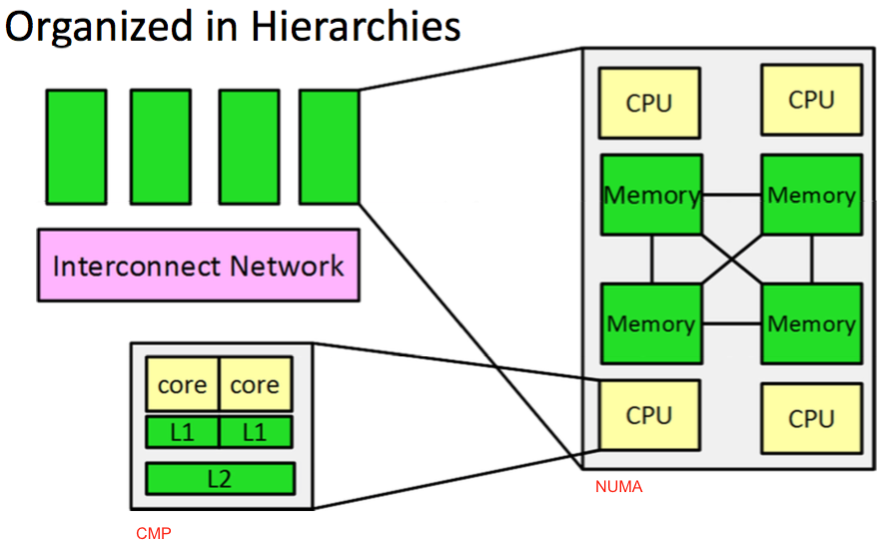 **Shared Data:** verschiedener Code hat Zugriff auf dieselbe Datenmenge – wenn ganz parallelisiert → jeder parallele Teil einen eigenen Datenpool auf den er zugreift → keine Koordination nötig. → reality: shared und non-shared data

**Shared Objects / work partitioning:** granularity – see 10.

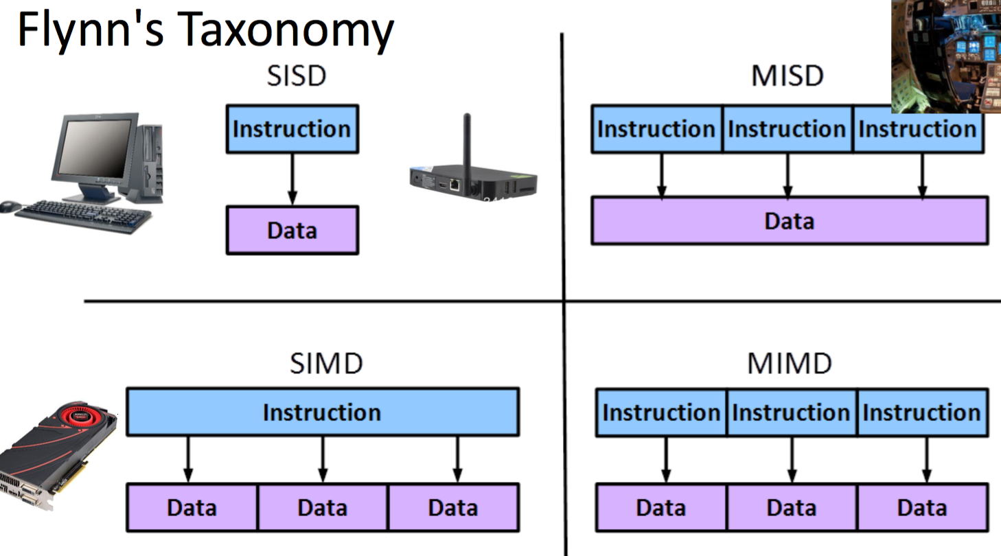single instruction single data, etc.

MIMD – e.g. NUMA

# Efficiency Calculations

If we did not care about performance, we would write sequential programs 🡪 much easier

Sequential part gets more and more important when there is more parallelism

(parallel) Speedup Sp on p CPUs : **Sp = T1 / Tp**

T1 = sequential execution time; Tp = execution time T on p CPUs

Efficiency: **Sp / p**

why Sp < p?

- programs may not contain enough parallelism

- overheads introduced by parallelization – typically associated with **coordination**

- architectural limitations

**Amdahl’s Law:**

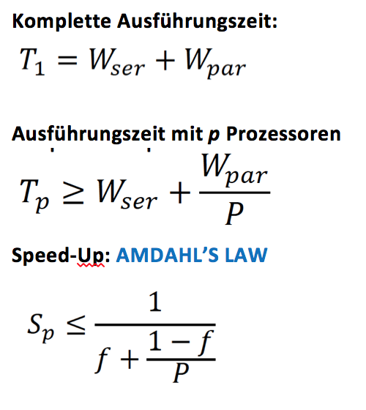

$$s_{p}=\frac{t_{1}}{t_{p}}$$

work-span formula:

$$t_{n}≤t_{infinity}+\frac{{t_{1}-t}_{infinity}}{n}$$

you can add the parallel overhead in the under the fraction in the speedup.

Wser = serial work = T(1) Wpar = parallelized work = *(1-f)/p*  
*f* are the non-parallelizable serial fractions of the total work

*p* = processors

🡪 Amdahl’s Law is used to predict the theoretical maximum speedup using multiple processors when only a given part of the program can be parallelized – fixed workload! 🡪 Sp ist nur ein Faktor!

**Limitations of Amdahl’s Law:** theoretical estimate based on a simple model 🡪 Hardware more complicated and it only applies to a fixed data set size

**Gustafson’s Law:**

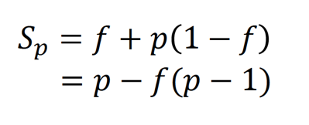

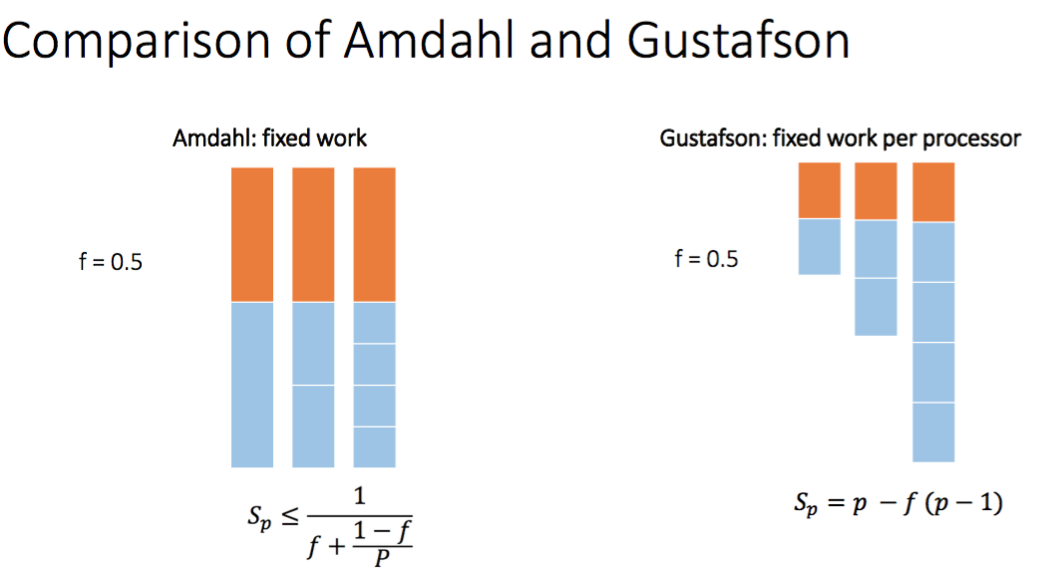**🡪 Amdahl:** splits everything in as many parallelized part as possible and distributes parts on processors available, **Gustafson:** splits everything in as many parallelized parts as processors are available

# Task Parallelism

CPU Pipeline: Instruction Fetch – Instruction Decode – Execution – Data Access – Writeback

**Throughput** = Input or output data rate / how often a unit exits the pipeline = *1/max(computation_time(stages))* → larger throughput is better

**latency** = time to perform a computation → lower latency is better

🡪 pipeline latency only constant over time if pipeline balanced

→ unbalanced pipeline: *upper bound = nr of stages * max(computation_time(stages))*

*🡪 throughput optimization may increase latency*

* **Fork-join programs** (thankfully) do not require much focus on sharing memory among threads → When using shared memory, you must avoid **race conditions** (producing undetermined program state and behavior due to un-synchronized parallel program executions)
* **sequential cutoff**: eliminates almost all the recursive thread creation (bottom levels of tree)

Data parallelism:

**work partitioning:** split up work into parallel tasks (unit of work); also task decomposition

**scheduling:** assign tasks to processors 🡪 **GOAL:** full utilization of all processors/execution units

🡪 in general: parallelism leads to faster execution of sequential programs

**threads: shared memory:** static fields, objects (communication between threads) → can be shared but don’t have to (most are not)

# Parallel Models

## Dynamic Task Graphs

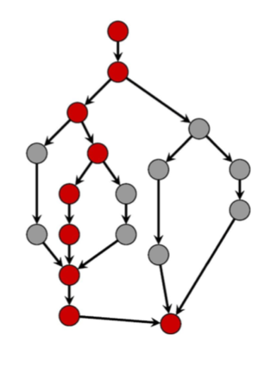 arrow: dependency, each node takes one time unit (t.u)

dynamic: tasks become available as computation progresses

**Tp** = execution time on p processors (depends on scheduler – other variables are fixed!=

**T∞  = span = critical path** → longest path from root to sink (time – not how many instances!) – how long it would take with infinitly many processors

**T1** = **work** - how long it would take 1 processor = sum of time cost of all nodes / as if sequential

**Speedup = T1 /Tp**

- if speed-up is P when varying P, *perfect linear speed-up* **(**means doubling P halves running time)

**parallelism = T1/T∞** = maximal possible speedup

asymptotically optimal execution: **Tp = O(T1/P + T∞)** (forkJoin guarantees that)

**🡪** first term dominates for small **P**, second term for large **P**

**🡪** *lower bound:* **Tp ≤ T1/P and Tp ≤ T∞**

*→ wider task graph is better*

🡪 *Parallel algorithms is about decreasing span without increasing work too much*

e.g. Fibonacci:

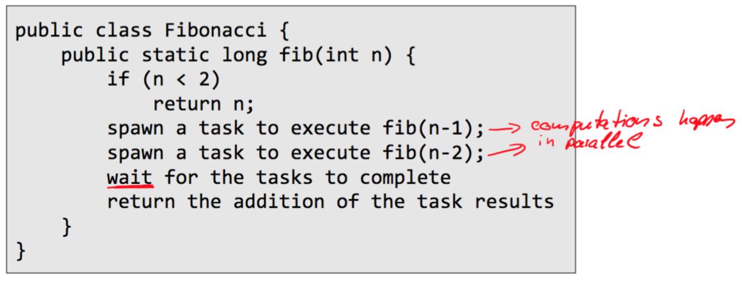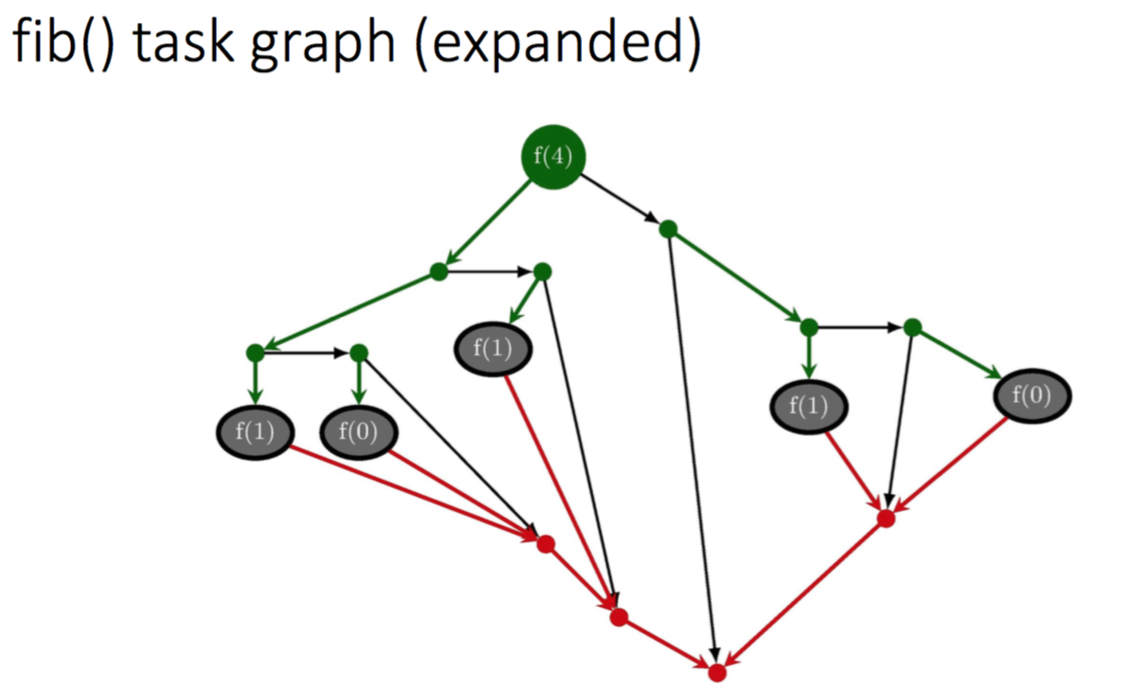

## Static graphs → Dataflow / stream programing

**Dataflow Programming Model**  **Pipeline**

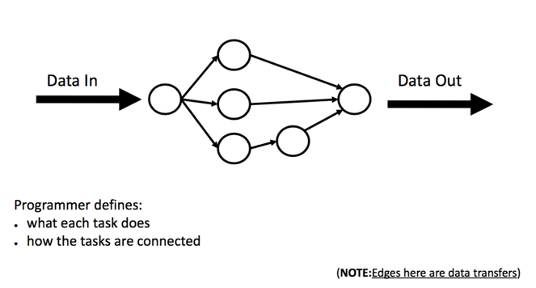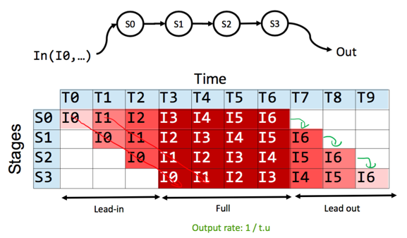

pipeline: in full utilization: output rate 1 item/ time unit, time unit determined by slowest stage 🡪 try to create pipeline where each stages takes same amount of time

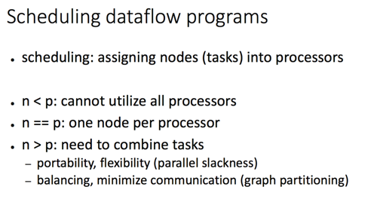

**Task Parallelism**: Programmer defines parallel tasks (what each task does and the task graph (dynamic or static)

**Data Parallelism**: Programmer defines operation on an aggregate of data items (e.g., arrays) 🡪 work partioning done by system 🡪 declarative: programmer describes what, not how

# Java Threads

**Threads:**

* independent sequences of execution, each has own local data
* has access to all the data in the process
* shared / unshared memory
* own program counter & call stack

A thread is at all times in one of the following states:

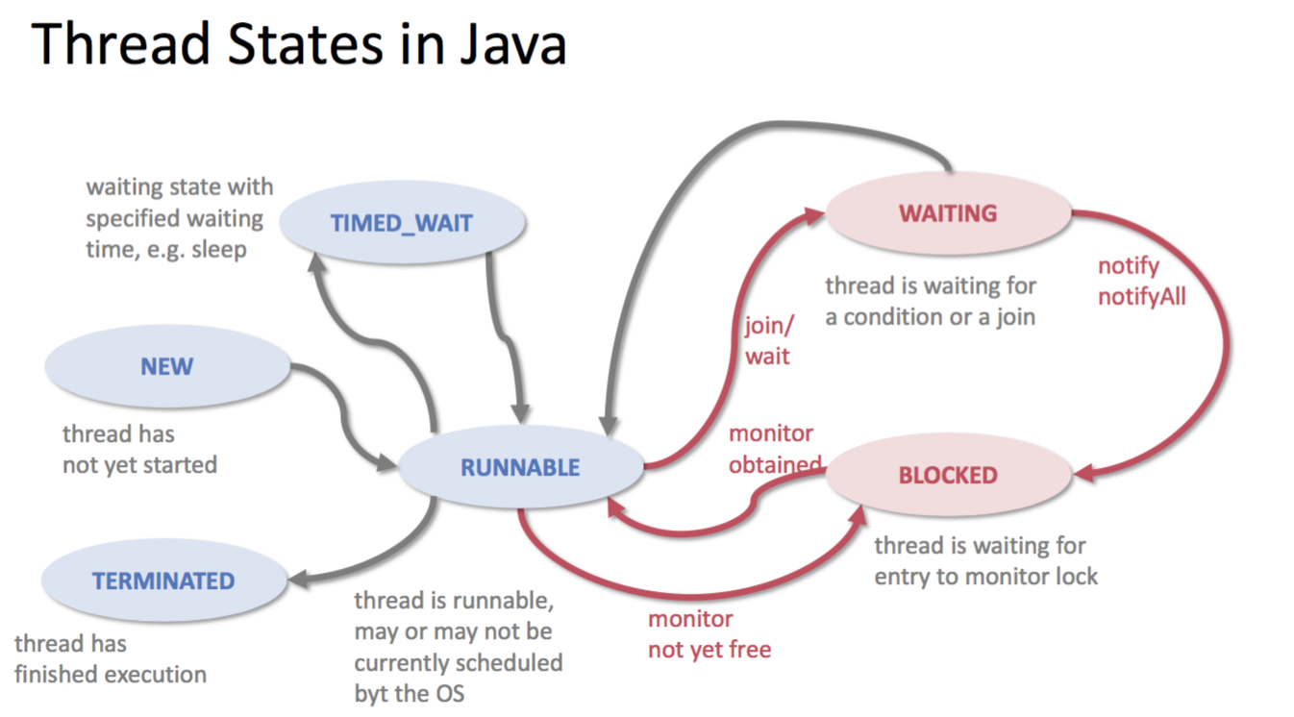

**Priority:** threads can have a priority between 1 and 10: threads[i].setPriority.MAX_PRIORITY   
→ helps operating system to determine the order Entwicklung which threads are scheduled

## create Java Threads

**Callable vs Runnable:**

Interface Runnable: void run()🡪 doesn’t return result

Interface Callable<T>: T call() 🡪 returns result

public class SumThread **extends Thread** {

**OR** public class SumThread **implements Runnable** {

int l, int h, int[] xs, int result; //arguments

public SumThread(int[] xs, int l, int h) {

super();

this.xs = xs;   
this.h = h;

this.l = l;

}

public void **run()** { //Override must have this type!

int size = h-l;

if (size < SEQUENTIAL_CUTOFF) {

for (i=l; i < h; i++)

result += xs[i];

return;

}

} else {

int mid = size / 2;

SumThread t1 = new SumThread(xs, l, l + mid);

SumThread t2 = new SumThread(xs, l + mid, h);

**t1.start();**

t2.start();

**t1.join();**

t2.join(); //(need try-catch block here)

result = t1.result + t2.result;

return;

}

}

}

## Java Executor Service

In general: using one thread per small task is highly inefficient 🡪 give task to another thread 🡪 Java executor service (Java’s implementation of a ThreadPool)

🡪 managing asynchronous tasks

🡪 ES very useful but not for divide & conquer / recursion (tasks create other tasks and then wait for results, when waiting, keeping threads busy, others need to run that recursion reaches bottom, system doesn’t know that tasks waiting need to be removed so that other tasks can run)

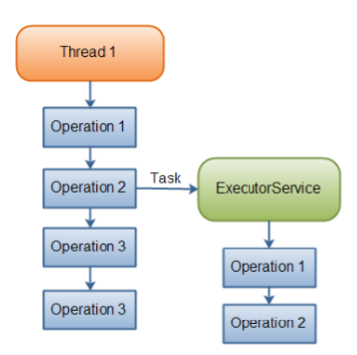 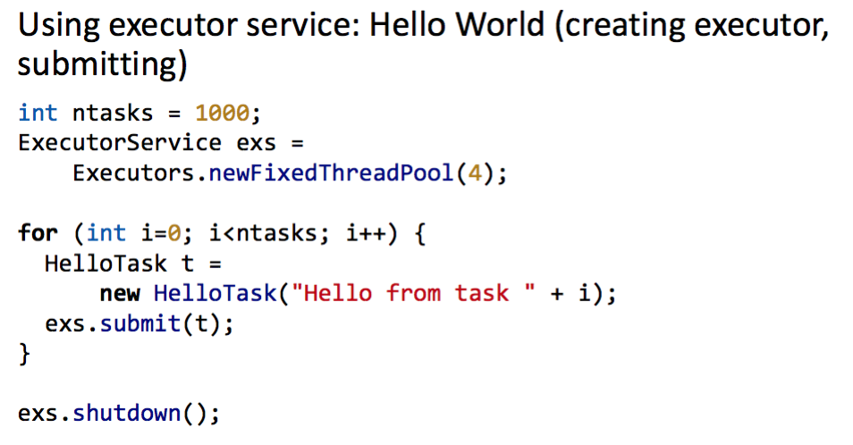

## ForkJoin Framework

Is designed to meet the needs of divide-and conquer fork-join parallelism

Don’t override run → @Override compute

**usual procedure:**

t.fork(); //create new task

…

result = t.join(); //return result when task is done (normal join just waits until

… other threads are finished)

t.invoke(); //execute the task computation without spawning a task

**Reductions:** produce single answer from collection via associative operator (e.g. max, leftmost, …)

**Map**: operates on each element of a collection independently to create a new collection of the same size 🡪 no combining results 🡪 no joining 🡪 no synchronization (e.g. good for ES)

Maps in ForkJoin: noresult combination in the end

Void compute() {

…

left.fork(); right.compute(); left.join(); }

class Globals {

static ForkJoinPool fjPool = new ForkJoinPool();

}

static int[] add(int[] arr1, int[] arr2) {

…

Globals.fjPool.invoke(xy)

Return ans;

}

🡪 Maps and reductions = work horses of parallel programming (2 most common patterns) 🡪 use them to describe parallel algorithms

**sequential cut-off:** when reaching a certain condition (e.g., array to determine maximum value of is of size 1000) you switch to a sequential algorithm (i.e., checking the elements one by one) to avoid the overheads associated with going parallel

**Directed Acyclic Graph**

Program with Fork/Join can be seen as DAG:

Nodes: Pieces of work / Edges: Source must finish before destination starts. Work is the time for the total amount of nodes(serial execution), and span is the time of the critical path(parallel execution).

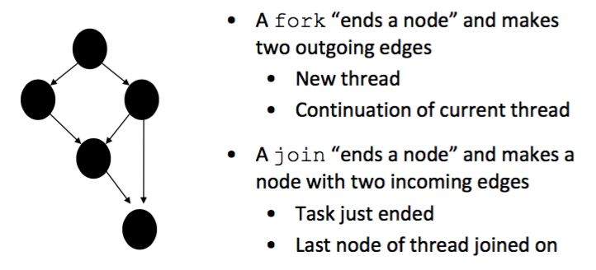

## Multithreading

Multiple threads share the same address space → threads share resources and can communicate easily → benefit: server can handle multiple clients simultaneously

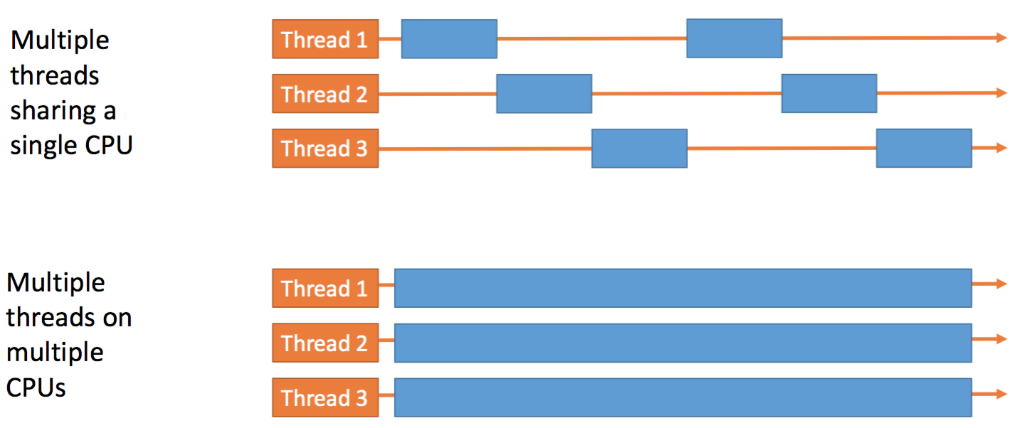

# Problems with Parallelism / vs Concurrency

**Concerns in parallel Programming:**

* expressing parallelism
* managing state (data)
* controlling / coordinating parallel tasks and data

→ to coordinate: enforce ordering: ask X uses result of task A; task X needs to wait for task A to finish (e.g. with barrier, blocking messages)

**Managing State Concerns:**

* shared vs distributed memory architectures (shared coordination needed, distributed not)
* which parallel tasks access which data – and how (e.g., READ or WRITE access)
* depending on the application: – tasks, then data – data, then tasks

**Parallelism vs Concurrency:**

**Parallelism:** *use extra computational resources to solve a problem faster (increasing throughput via simultaneous execution)* 🡪 work needs resources 🡪 requires coordination

**Concurrency:** *correctly and efficiently manage access to shared resources (from multiple possibly-simultaneous clients)* 🡪 requests need resources 🡪 requires synchronization

🡪 if parallel computations need access to shared resources, then the concurrency needs to be managed

Concurrency

# Managing State

*Be able to reason and explain why mutual exclusion is required / beneficial.*

*Know, understand and be able to reproduce definitions of deadlock, starvation and livelock.*

**Managing State:**

* **immutability:** data doesn’t change
* **Isolated mutability:** data can change but only 1 execution context can access them
* **mutable/shared data:** data can change, access for all executions

🡪 protect state by allowing only one thread to access it at a time = **mutual exclusion =** *“Statements from the critical sections of two or more processes must not be interleaved.”*

**critical section** (CS) = *piece of code that may be executed by at most one process (thread) at a time* with the following conditions: mutual exclusion, freedom from deadlock, freedom from starvation

**deadlock:** processes are blocked because each process waits for another of these to proceed

**livelock:** competing processes detect a (potential) deadlock but make no progress while trying to resolve it <-> polite lock

**starvation:** repeated but unsuccessful attempt of an unblocked process to continue its execution

**convoying**: thread holding a resource R is descheduled while other threads are waiting for R

**priority inversion:** lower priority thread holds a resource that a high priority thread is waiting on

**properties of mutual exclusion:**

* safety property 🡪 at most one process executes the CS code
* liveness 🡪 acquire_mutex must terminate in finite time when no process executes critical section code

**State Space Diagram:**

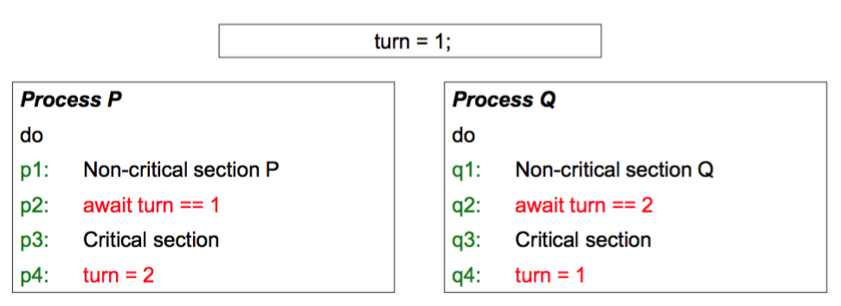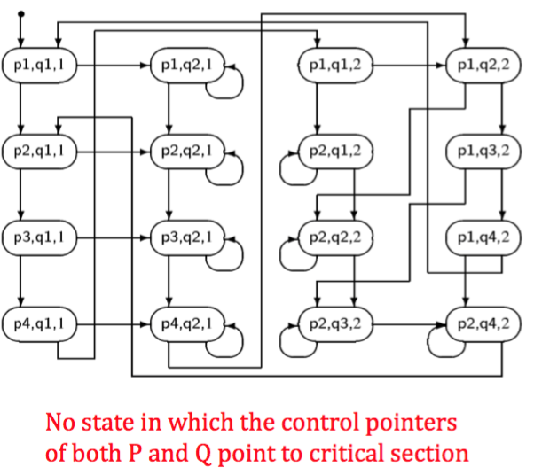🡪 mutual exclusion holds

## Locks

*Know locks conceptually (and in Java). Understand the effect of synchronization.*

Public interface Lock {

Public void lock(); //entering CS

Public void unlock(); //leaving CS

newLock

.acquire //blocks if lock is already held <-> mutex.acquire

.release //makes lock free <-> mutex.release

**🡪 java.util.concurrent.Lock**

**Reentrant Lock aka recursive Lock**

A thread cannot acquire a lock owned by another thread, but a lock that it already owns. Allowing a thread to acquire the same lock more than once enables reentrant synchronization.

* Remembers thread count
* When lock goes from not-held to held -> count = 0

if current holder calls acquire: doesn’t block and increments count

if release count decremented,not held

**🡪 java.util.concurrent.ReentrantLock**

**Thread safety:** only one thread can access one object at the time and change something!

**Thread safe object:** object which doesn’t get in an unstable state when methods called, e.g. locks, semaphores, atomic operations

**memory location:** thread local: keep as much data local as possible -> data at thread, if no communication needed

**synchronized**

When a thread invokes a synchronized method, it automatically acquires the intrinsic lock for that method's object and releases it when the method returns.

**synchronized** (expression/this) {

statements

}

🡪 locks whole method, often use **try {...} finally {...}** to avoid forgetting releasing lock when there’s an exception

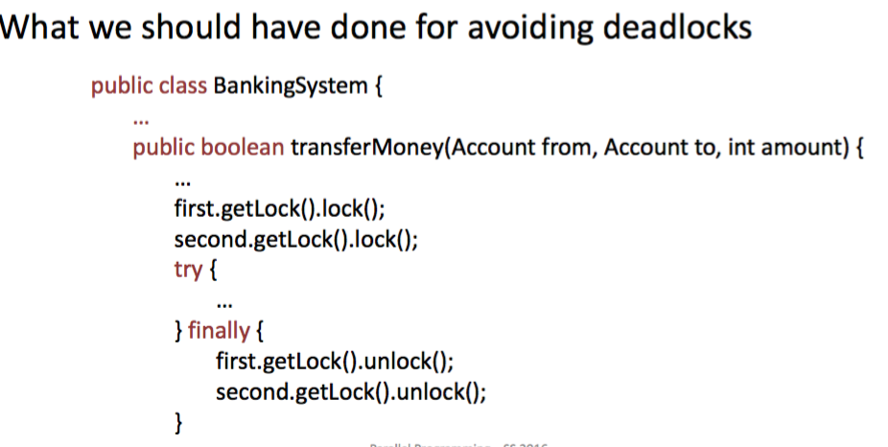

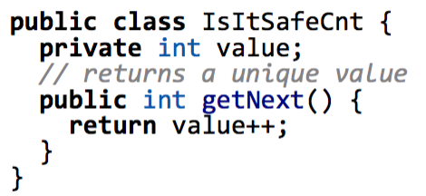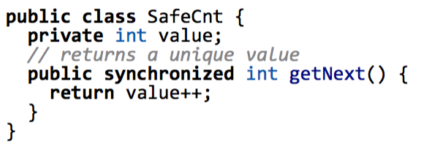

not thread safe thread safe

With synchronization data races and bad interleavings can be prevented, as well as mutual exclusion is ensured. But there is no given order of when which thread is processed.

🡪 Basic Synchronization Rule: *Access to shared and mutable state needs to be always protected!*

## Data Races and Bad Interleavings

*Know the difference between races and bad interleavings. Be able to spot races and bad interleavings in Java code.*

**Race condition** occurs when computation result depends on scheduling 🡪 some intermediate state (read/write or write/write) messes up concurrent thread that sees state

**Bad interleaving** caused by unfavorable execution order of a multithreaded algorithm that makes use of otherwise well synchronized resources

## Guidelines for unavoidable concurrency

*Know the guidelines for concurrent programming in Java.*

* No data races
* For each location needing synchronization have a lock that is always held when reading or writing 🡪 consistent locking
* Start with coarse-grained and move to fine-grained performance only if contention on coarser locks becomes an issue
* Don’t use expensive computations or I/O in critical sections
* Decide what operations need to be atomic

## Peterson Lock and Bakery Algortihm

*Know Peterson's Algorithm and its properties. Understand the proofs. Understand the mechanism of locks based on Peterson.*

Peterson's algorithm allows two or more processes to share a single-use resource without conflict, *using only shared memory for communication*. 2 variables: flag, turn. If flag from process n := true 🡪 n wants to enter CS. Entrance is granted for process P0 if P1 does not want to enter its CS or if P1 has given priority to P0 by setting turn to 0.

*P0 and P1 can never be in the critical section at the same time:* If P0 in CS, then flag[0] = true. In addition, either flag[1] is false (meaning P1 has left its critical section), or turn is 0 (meaning P1 is waiting “I’m interested but you go first”).

As no state can satisfy both turn = 0 and turn = 1, there can be no state where both processes are in their CS.

*Understand the properties of the bakery Algorithm. No need to be able to reproduce the algorithms in Java from scratch.*

process gets number with a value greater than all outstanding tickets - CS Entry: Wait until ticket number is lowest. In case another thread has the same number, the thread with the smallest i will enter the critical section first. 🡪 but: not wait-free

# Atomicy

## Atomic Registers

*Know the properties of atomic registers and be able to reproduce them in a semi-formal way. Know Java's volatile. Know Java's Atomic memory references. Know what a "safe register" is.*

**Register r**: basic memory object, shared or unshared

r.read()

r.write(v) use **AtomicInteger**, **AtomicIntegerArray**

🡪 An atomic action effectively happens at once i.e. action cannot stop in the middle nor interleaved

🡪 It either happens completely, or it doesn’t happen at all.

🡪 No side effects of an atomic action are visible until the action is complete

but: even with atomic registers there can be non-determinism of programs because nothing is said about the order of effect times for concurrent operations

Hardware support for atomic operations: TAS, CAS

**atomic vs volatile:**

🡪 atomicy vs visibility:

with volatile: prevents compiler to reorder instruction which involves write and subsequent read of the volatile variable 🡪 volatile doesn’t make it atomic, other threads can see an intermediate result but is set thread-wide atomically

private volatile int x = 0;

**SWMR** (Single Writer Multiple Reader): only one concurrent write but multiple concurrent reads allowed

**Safe Register**

* any read not concurrent with a write returns the current value of r
* any read concurrent with a write can return any value of the domain of r

if any read concurrent with writes can only return a value of one of the writers then the register is

called *regular*

## Read-Modify-Write Operations (CAS, TAS)

*Understand the difference between RMW and Atomic Registers. Know the semantics of CAS and TAS. Know Java's CAS for Atomic variables.*

*Know how to implement a spinlock with CAS and TAS, be able to understand Java code with CAS/TAS, be able to implement one lock (e.g. using TAS) with Java from scratch.*

Test-And-Set (TAS) & Compare-And-Swap (CAS): Atomic instructions are typically several orders of magnitude slower than simple read & write operations!

Enable of a mutex with O(1) space and are used in lock-free programming.

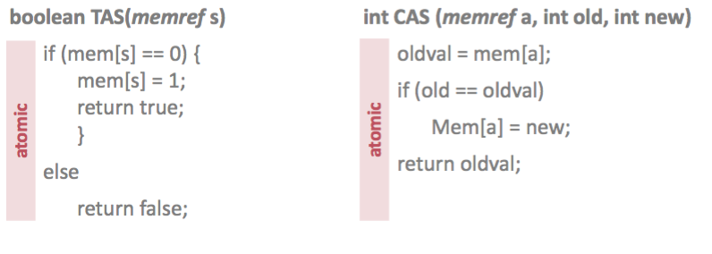

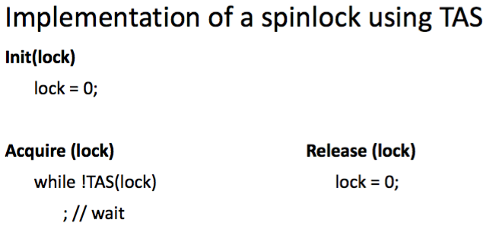 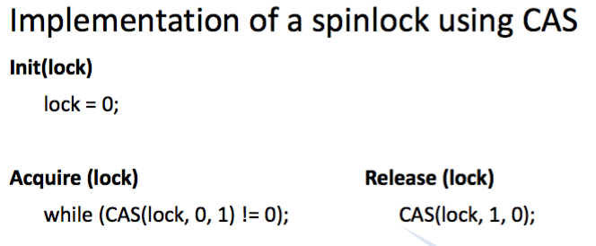

*in Java:*

**java.util.concurrent.atomic.AtomicBoolean**

boolean set();

boolean get();

boolean compareAndSet(boolean expect, boolean update); //atomically set to value

update iff current value is expect

boolean getAndSet(boolean newValue) //sets newValue and returns

previous value

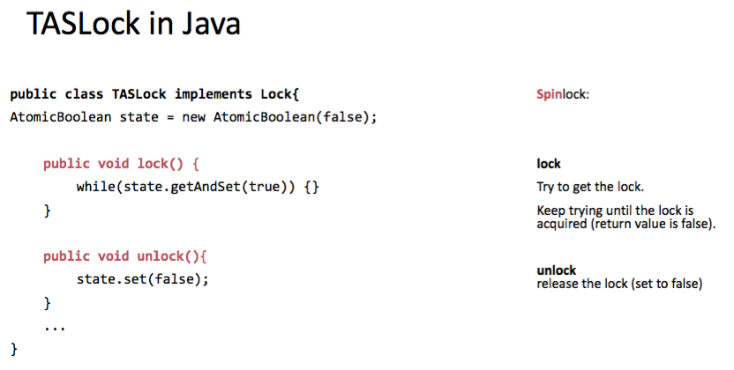

## Backoff

*Understand and be able to explain the problem of contention, understand and be able to explain the idea of a backoff.*

**contention:** threads fight for the bus during call of getAndSet() 🡪 solution: TTAS

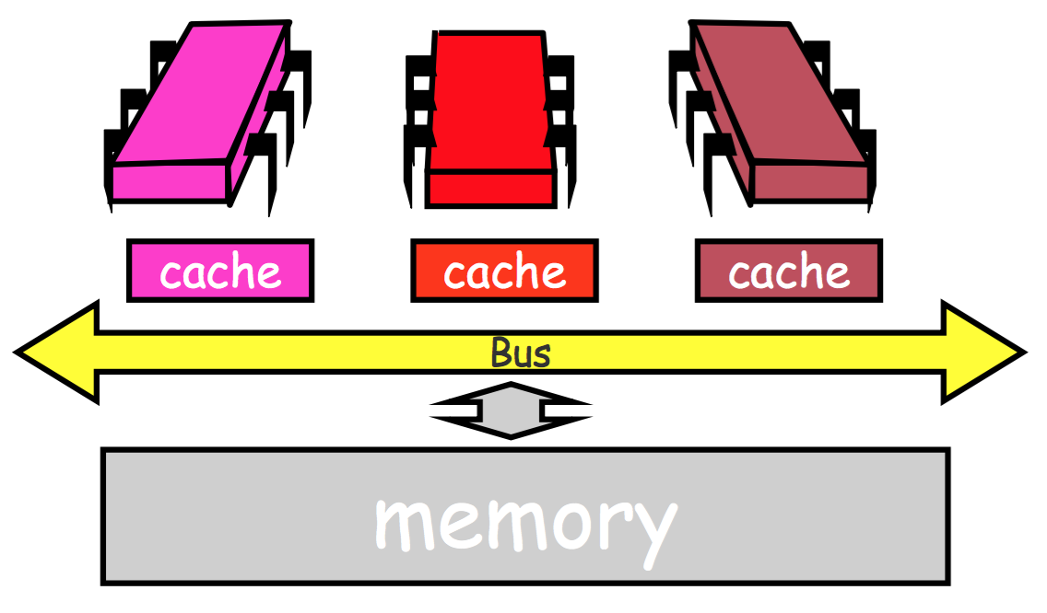 cache coherency protocol invalidates cached copies of lock on other processors

**backoff**: many threads fight for access to the same resource 🡪 slows down progress globally and locally 🡪 **threads go to sleep with random duration, increase expected duration each time the resource is not free.**

Exponential Backoff:The retries exponentially increase the waiting time up to a certain threshold.

# Beyond Locks

## Deadlocks

*Be able to spot simple deadlock scenarios and know how to solve them. Know how to detect a deadlock conceptually. Be able to explain the Dining Philosopher's Problem and the banking Example.*

**Fixing deadlocks:**

* Non-overlapping smaller critical sections
* One lock for all (not very efficient)
* Lock ordering
* Try {} … finally {}
* Global ordering of resources 🡪 whole program has to obey order to avoid cycles 🡪 find cycle in dependency graph to find deadlock

## Semaphores and Barriers

*Know the semantics. Know how to build a lock with semaphores. Know how to implement rendevouz and Barrier with semaphores.*

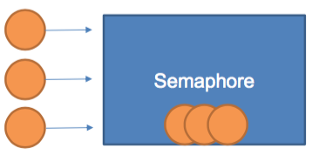**semaphore** restrics number of simultaneous users of a shared

resource up to a maximum number;

N Threads have permit to a semaphore, others will wait blocking

until someone leaves the semaphore

Acquire(S) { wait until S > 0, dec(S) }

Release(S) { inc(S) }

🡪 *atomic* operations

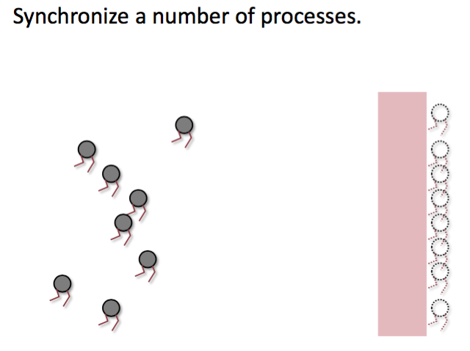**barrier** waits until a number of threads has reached barrier

Acquire(B)

Release(B)

Acquire(mutex)

…

Acquire(B), release(B)

Signal(mutex)

…

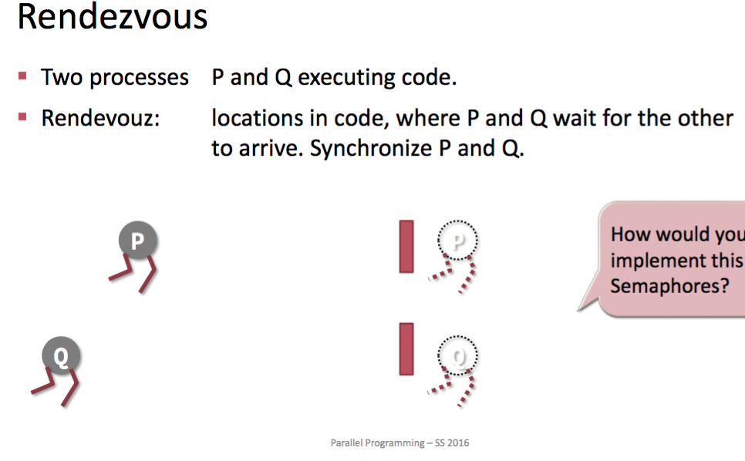**Rendezvous:**

P and Q executing code 🡪 Rendezvous: locations in code where P

and Q wait for the other to arrive 🡪 synchronize P and Q

## Producer/Consumer Pattern

*Understand its role in concurrent systems, know an implementation with circular buffer, understand difficulty to implement only with locks, understand semaphore's role in this context*

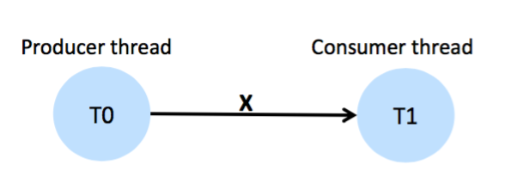synchronization needed

while(true) {

input = q_in.dequeue();

output = do_something(input);

q_out = enqueue(output)

}

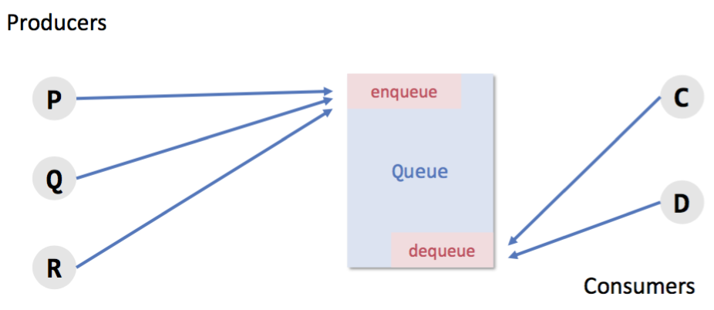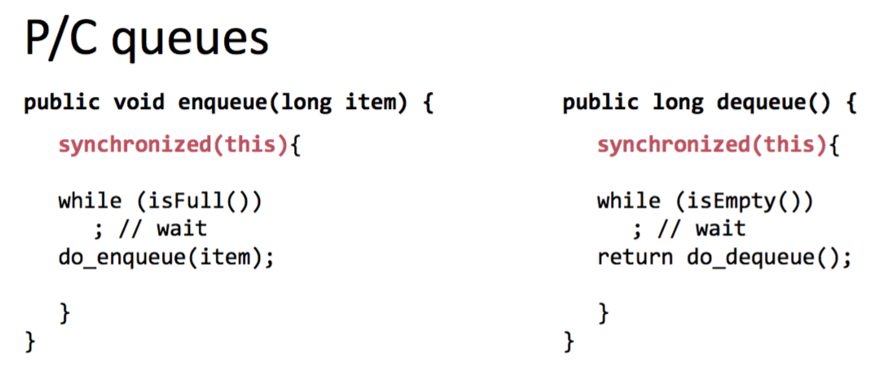

implementation with locks/semaphores 🡪 **deadlock**! as semaphores are unstructered and therefore deadlock easily arises 🡪 use monitors

🡪 P/C is a fundamental parallel programming pattern, can be used to build data-flow parallel programs E.g, pipelines.

## Monitors and Conditions

*Understand role of monitor and conditions in the context of P/C Pattern. Understand Java’s signal and continue implementation of Monitors. Understand and know the programming guidelines for monitors and conditions. Understand the Sleeping Barber Variant of P/C.*

All the methods of a monitor are executed with mutual exclusion 🡪 at most one thread can execute a method of the monitor at the same time. Monitors also can have waiting conditions. 🡪 doesn't depend on the number of processes and you don’t need to release something like a mutex

**.wait()** // the current thread waits until it is signaled

**.notify()** // wakes up one waiting thread

**.notifyAll()** // up all waiting threads

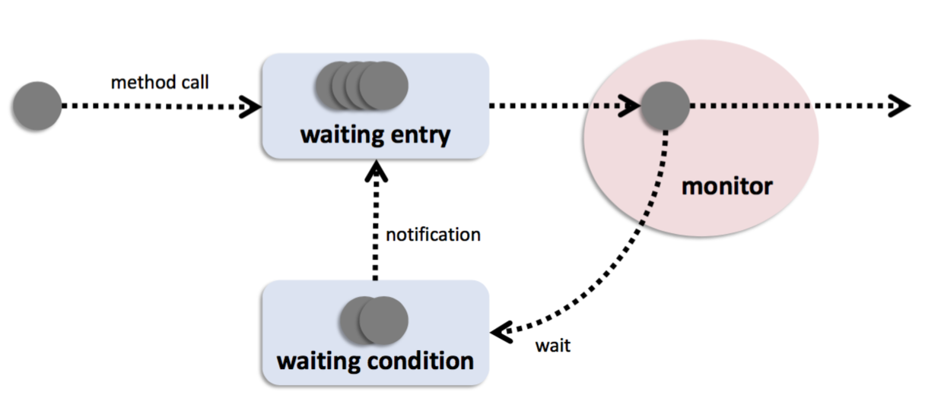 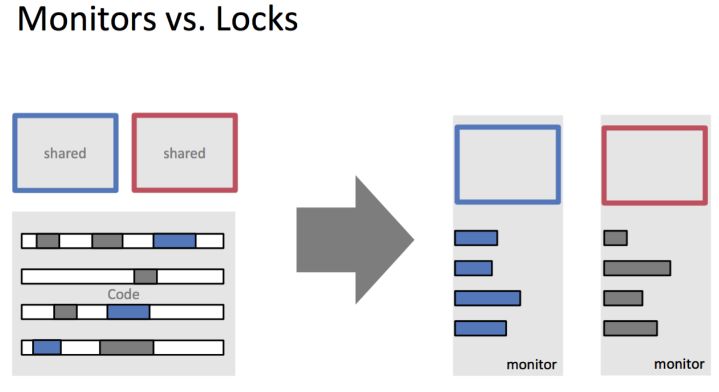

**signal and wait**

signalling process exits the monitor (goes to waiting entry queue)

signalling process passes monitor lock to signalled process

**signal and continue**

signalling process continues running

signalling process moves signalled process to waiting entry queue

other semantics: signal and exit, signal and urgent wait ...

**Monitors in Java**

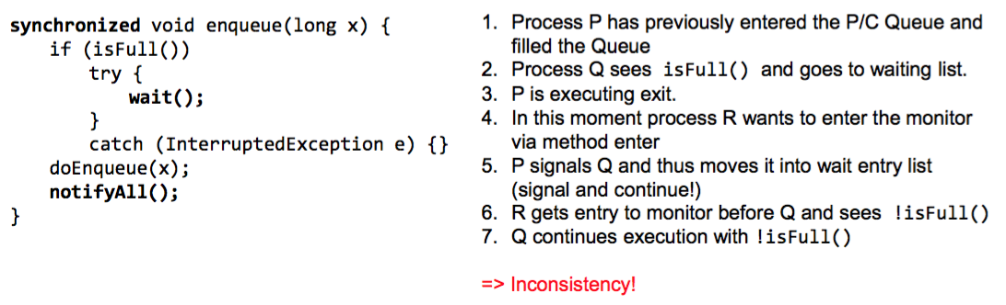

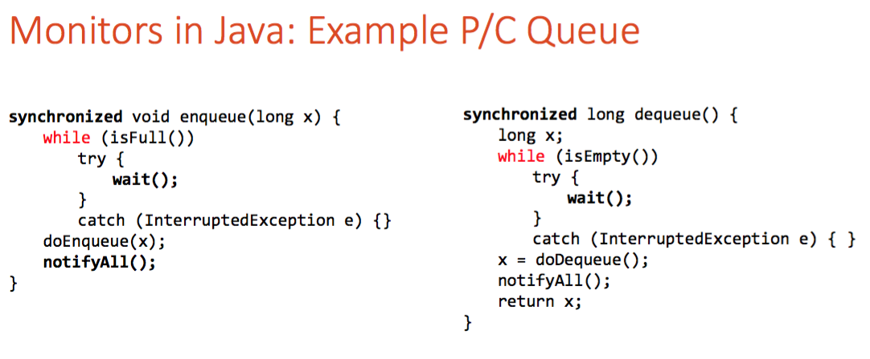

Disadvantage of the solution P/C queue: nonfull and nonempty signal will be sent in any case, even when no threads are waiting.

🡪 **Sleeping barber variant:** additional counters for checking if processes are waiting:

m ≤ 0 : buffer full & -m producers (clients) are waiting

n ≤ 0 : buffer empty & -n consumers (barbers) are waiting

**Lock Conditions:**

Java Locks provide conditions that can be instantiated 🡪 thread always needs to check condition

final Lock lock = new ReentrantLock();

Condition notFull = **lock.newCondition();**

**.await()** // the current thread waits until condition is signaled

**.signal()** // wakes up one thread waiting on this condition

**.signalAll()** // wakes up all threads waiting on this condition

## Readers/Writers Locks

*Understand the reason why R/W locks are useful. Know the problems of R/W locks (fairness) and how to deal with them.*

**Idea: many can read but only one can write**

**🡪** Lock has 3 states: not held, held for reading, held for writing

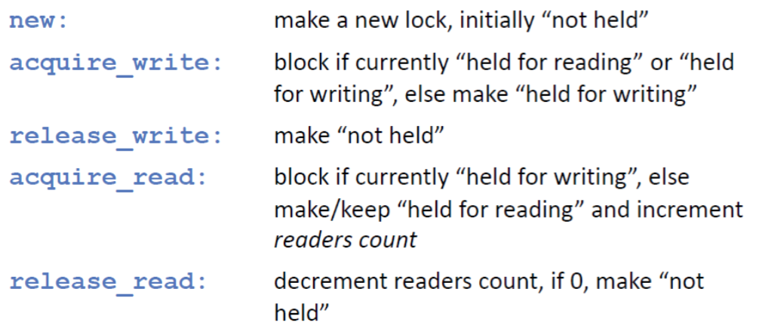

problem:

strong priority to readers: when reader reads, other readers can enter but no writer

strong priority to writers: priotiry lane 🡪 reader can only read if no writer is waiting

fairer solution:

* when a writer finishes, the number k of currently waiting readers may pass.
* when the k readers have passed, the next writer may enter (if any), otherwise further readers may enter until the next writer enters (who has to wait until current readers finish).

🡪 **java.util.concurrent.locks.ReentrantReadWriteLock**

## Lock Granularity

*Understand the problems of coarse grained locking and the path to fine-grained locking, optimistic synchronization and lazy synchronization.*

*Know the principles of add and remobe for a list based set implemenation. Understand the role of validation.*

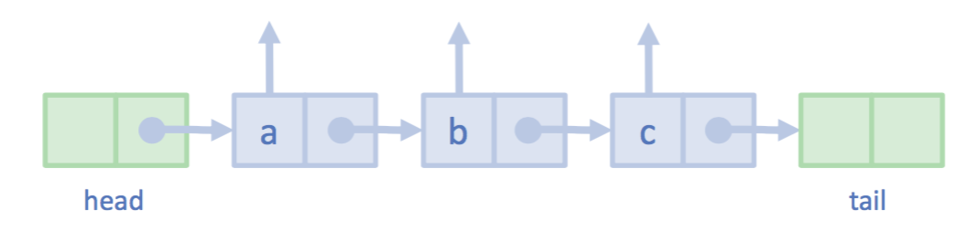 head and tail always there

**Coarse grained locking:**

with synchronized 🡪 whole methods are locked 🡪 almost sequential 🡪 much time needed

**Fine grained locking:**

Hand-over-locking: 2 threads can never cross 🡪 go along list

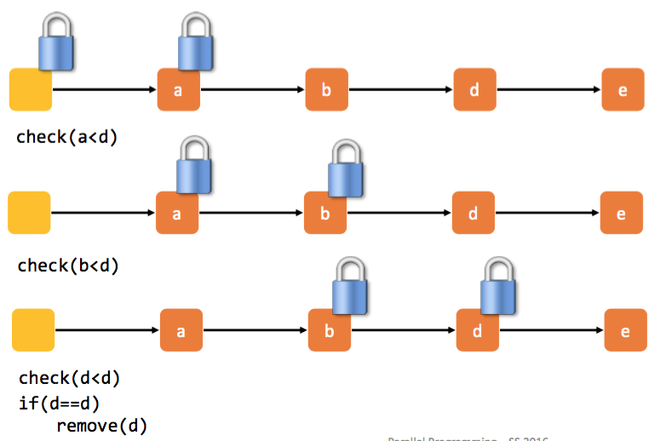

🡪 Multiple readers and writers can be actively doing work in the same list.

🡪 Readers and writers that are traversing the list in the same order will not pass each other.

🡪 locks taken on parts of the list won't deadlock with each other, because multiple locks are acquired in the same order.

**Optimistic synchronization:**

Find nodes without locking, then lock predecessor and current and validate 🡪 look if it is not held

*Good:* No contention on traversals. Traversals are wait-free. Less lock acquisitions.

*Bad:* Need to traverse list twice, contains() method needs to acquire locks

**Lazy synchronization:**

Like optimistic locking, Scan list, lock predecessor and current, Logical delete: mark current node as removed, then physical delete: redirect predecessor's next

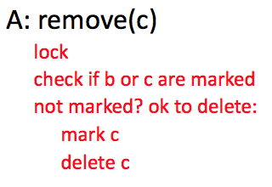 🡪 scan only once, contains() never locks

🡪 see exercise sildes 10

# Without locks

**Disadvantages of Locking:**

* Deadlocks: threads blocking each other
* Convoying: scheduler can deschedule a thread holding a lock while others wait for the lock.
* Priority Inversion
* Performance issues (**overhead**: work used to implement, coordinate locks)
* Locks are not composable – cannot combine **n** thread-safe operations

*🡪 A lock-free algorithm does not automatically provide better performance than its blocking equivalent!* Atomic operations are expensive and contention can still be a problem. Backoff.

## Lock-Free Synchronization

*Be able to explain the problems of spinlocks. Know, understand an be able to reproduce definitions of lock-freedom and wait-freedom. Know how they relate to starvation-freedom and deadlock-freedom.*

**Spinlock:** lock which causes a thread trying to acquire it to simply wait in a loop ("spin") while repeatedly checking if the lock is available.

**🡪 Problems with Spinlocks:** Scheduling fairness / missing FIFO behavior;Computing resources wasted 🡪 overall performance degraded;No notification mechanism.

**Scheduled Locks:** Locks that suspend the execution of threads while they wait. Semaphores, mutexes and monitors are typically implemented using a scheduled lock

* Require support from the runtime system (OS, scheduler).
* need to be protected against concurrent access, if not implemented lock-free
* have a higher wakeup latency.

**wait-freedom:** all algorithms eventually make progress. Implies freedom from starvation.

implies

**lock-freedom:** at least one algorithm always makes progress even if other algorithms run concurrently. Implies system-wide progress but not freedom from starvation.

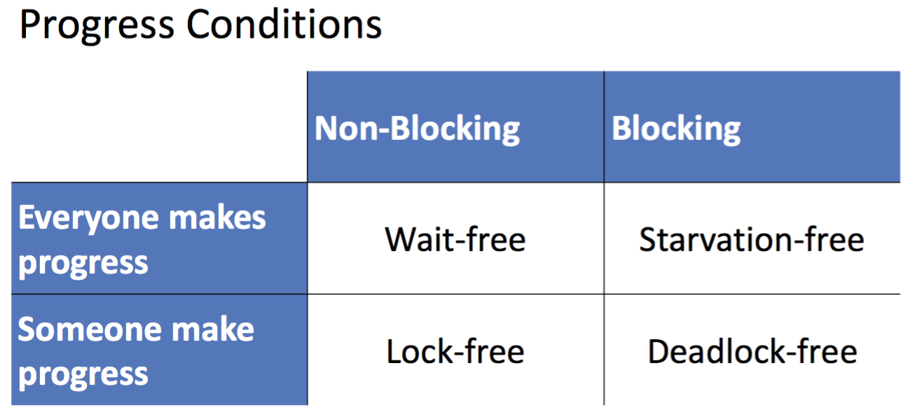

## Non Blocking Algorithms

*Know how to implement a lock-free counter and a lock free stack, without considering the ABA problem yet. Understand the principal limitation of CAS and how it relates to the implementation of complex lock-free data structures (unavailability of “multi-compare and set”)*

**Non-blocking:** failure or suspension of one thread cannot cause failure or suspension of another thread! 🡪 threads are independet from each other, make progress, don’t have to wait for each other

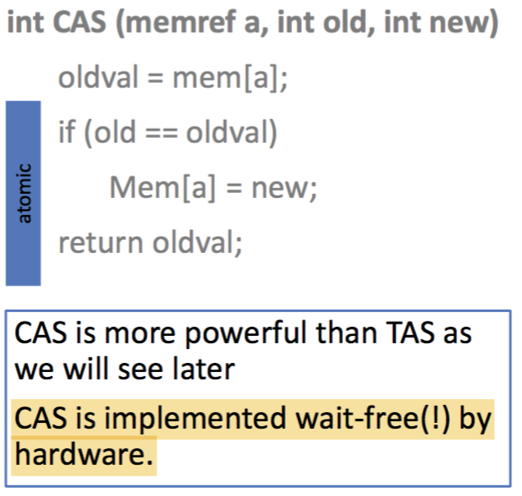 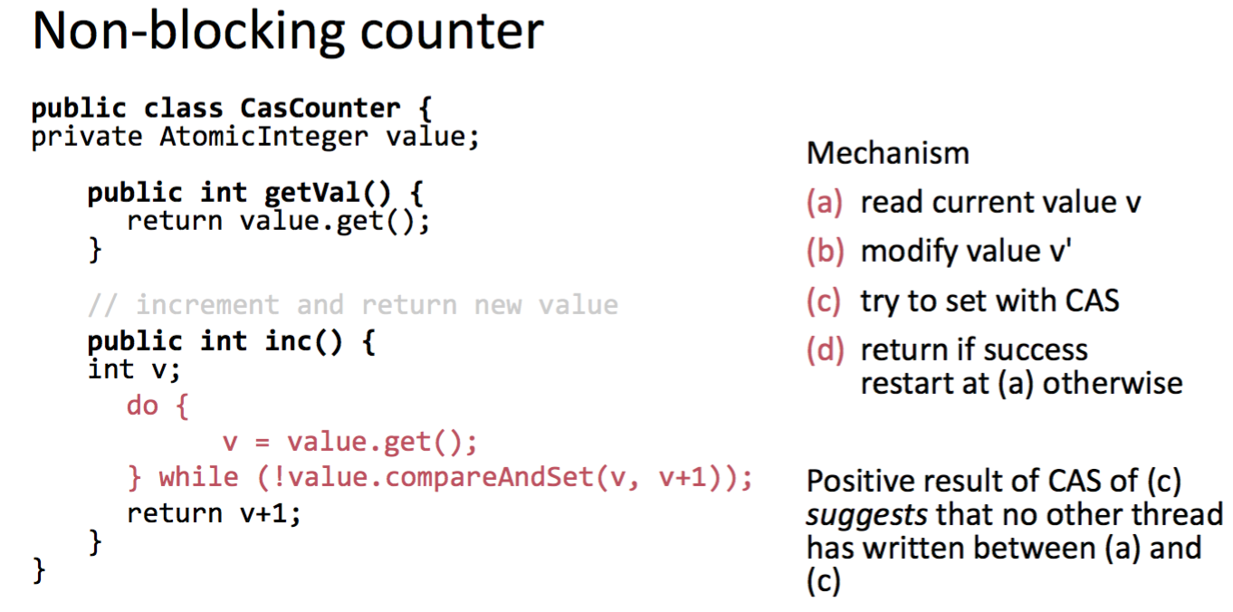

Positive result of CAS suggests that no other thread has written 🡪 it is THE mechanism to check for exclusive access in lock-free programming.

## Unbounded Queue

*Be able to explain how the unavailability of DCAS provided a problem in writing an algorithm for the unbounded queue and how this was solved here. Understand the ABA problem and be able to give an example. Be able to detect an ABA problem in a reasonably simple example with hint.*

**DCAS** (double compare and swap) to be able check two conditions at once. 🡪 when implementing a lock-free queue like this, we run into problems because of potentially simultaneous updates of **head, tail, tail.next** (see slides 20, p. 10)

Idea: Sentinel at the front 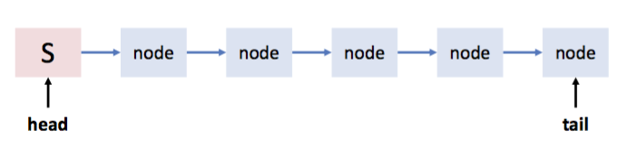

🡪 still have to update two pointers at a time! Enqueuers work on tail and dequeuers on head 🡪 tail might (transiently) not point to the last element 🡪 Unacceptable that any thread has to wait for the consistency to be established

Solution: Queue node needs atomic next pointer: **public AtomicReference<Node> next;**

**public class NonBlockingQueue extends Queue {**

AtomicReference<Node> head = new AtomicReference<Node>();   
AtomicReference<Node> tail = new AtomicReference<Node>();

One more possible inconsistency: thread A is enqueues an element to an empty list, but has not yet adapted last 🡪 thread B dequeues (the sentinel) S node 🡪 last points to a dequeued element (see slides 20, p. 20)

**Final solution:** (see slides 20, p. 22/23) 🡪 Threads help each other making progress

ENQUEUE: Create the new node 🡪 Read current tail as last and next as last.next 🡪 Try to set last.next from null to node, if success then try to set tail 🡪 Ensure progress by advancing tail pointer if required and retry

DEQUEUE: Read head as first, tail as last and first.next as next 🡪 Check if queue looks empty (1) really empty: return, (2) next available: advance last pointer 🡪 If queue is not empty, memorize value on next element and try to remove current sentinel 🡪 Retry if removal was unsuccessful

**ABA Problem:**

At stack, assume we do not want to allocate for each push and maintain a Node-pool instead. Only difference to Stack above: NodePool is in-place.

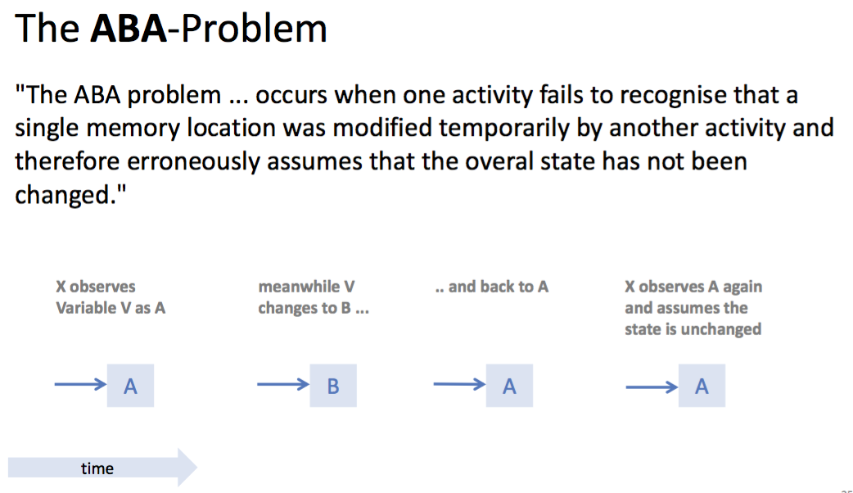

## Hazard Pointers

*Understand the concept of HP. No need to reproduce Java code. Know where HP are stored and how many you need. Don’t consider pointer tagging.*

The ABA problem stems from reuse of a pointer P that has been read by some thread X but not yet written with CAS by the same thread. Modification takes place meanwhile by some other thread Y.

How to solve the ABA problem?

* DCAS (double compare and swap)
* Garbage Collection
* Pointer Tagging
* Hazard Pointers:
  + before X reads P, it marks it hazarduous (= risky) by entering it in one of the n (n= number threads) slots of an array associated with the data structure (e.g. the stack)
  + When finished (after the CAS), process X removes P from the array
  + **Before a process Y tries to reuse P, it checks all entries of the hazard array**

The hazard pointers are placed in **thread-local storage**. When thread-local storage can be replaced by processor-local storage, it scales better.

# Theory of Concurrency

*Understand and be able to explain the problem with sequential specifications in the context of parallel programming.*

Objects – Sequential Specifications:

An **object** is a container for data and provides a set of methods to manipulate data. An object has a well defined **state** being modified during method invocations.

Defining the objects behavior in terms of a set of **pre- and postconditions** for each method is inherently **sequential**. A **Method Call is** the interval that starts with an invocation and ends with

a response. Method call is called pending between invocation and response.

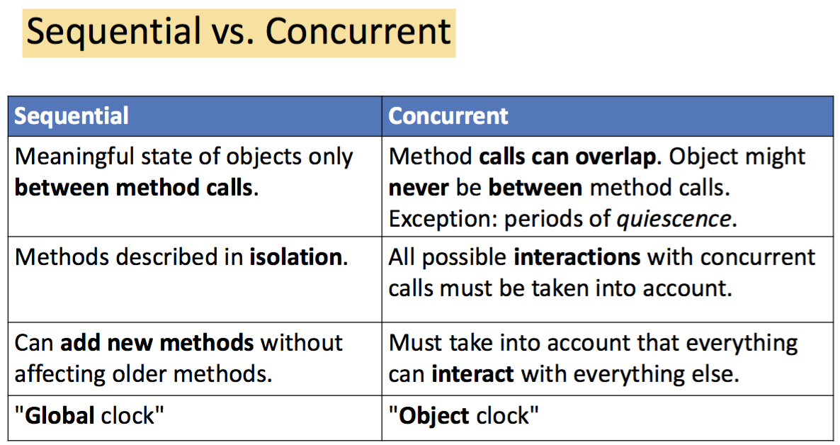

## Linearizability

*Be able to informally explain the concept of linearizability. Be able to identify linearization points in parallel code. Understand and be able to explain the implications of the Composability Theorem. No need to provide formal proofs.*

Linearizability provides the illusion that each operation applied by concurrent processes takes effect instantaneously between its **invocation and its response**. An object for which this is true is called **linearizable.**

🡪 Linearizability is the generalization of this intuition to general objects, with or without mutual exclusion 🡪 So, we define an object to be *correct if this sequential behavior is correct.*

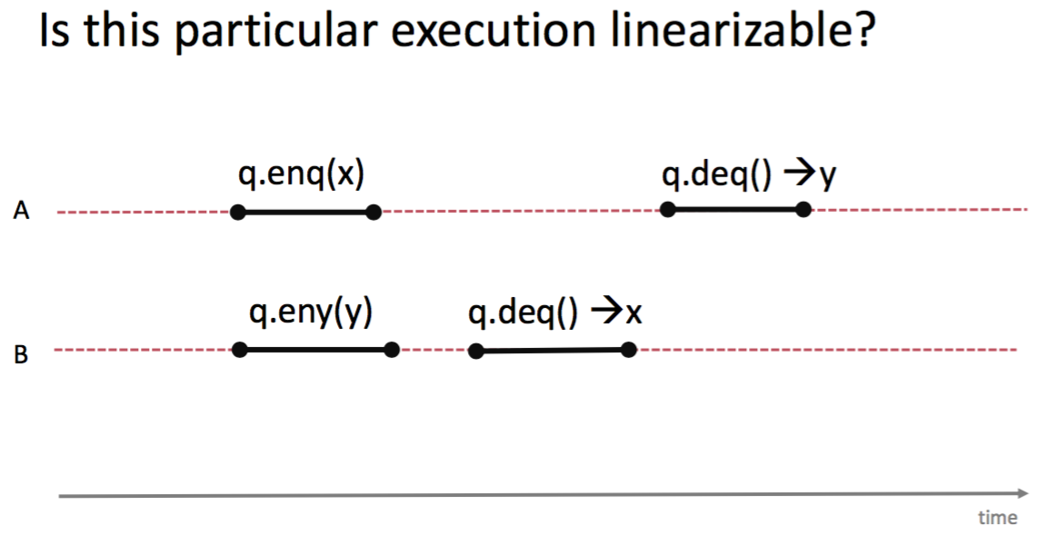 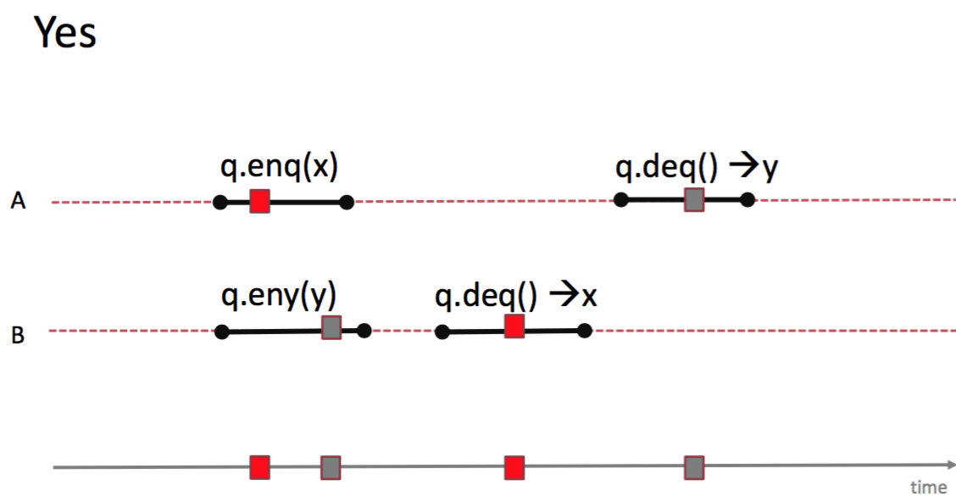

method call *precedes* another vs they *overlap*

**linearization points** can often be specified, but they may depend on the execution

* when locks are released
* Wait free Queue: enqueue/dequeue points
* 🡪 identify where atomic method happens – critical section / machine instruction

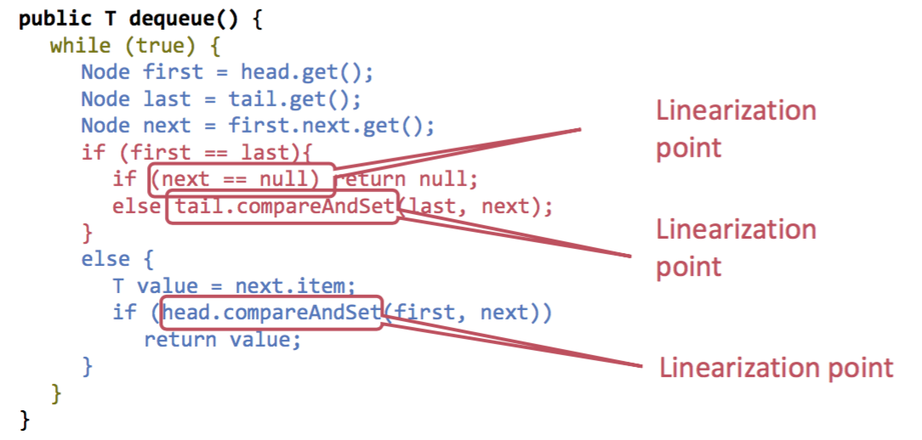

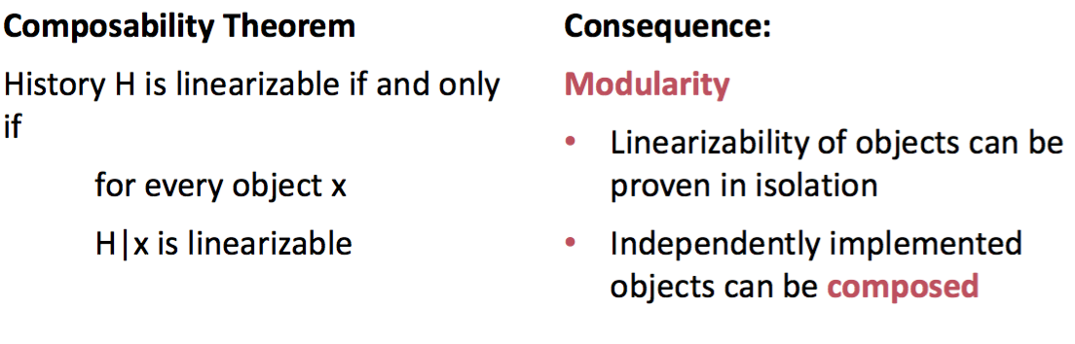 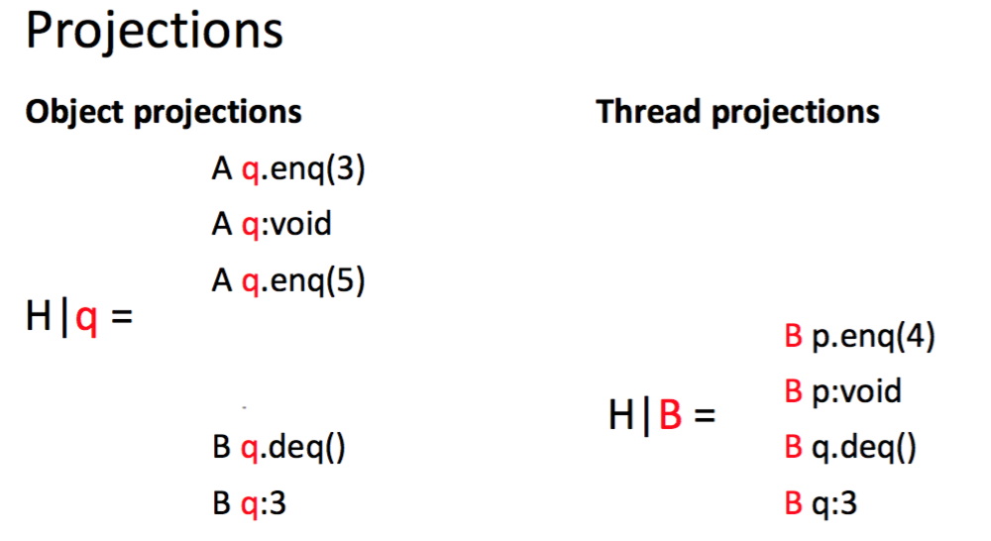

## Sequential Consistency

*Be able to superficially explain why typical hardware does not implement sequential consistency. Understand the difference to linearizability. Understand and be able to explain how it relates to Java’s “volatile” keyword.*

History 𝐻 is **sequentially consistent** if it can be extended to a history 𝐺.

Real-World Hardware Memory 🡪 *Weaker than sequential consistency*, but you can get sequential consistency at a price 🡪 Concept of Linearizability more appropriate for high-level software

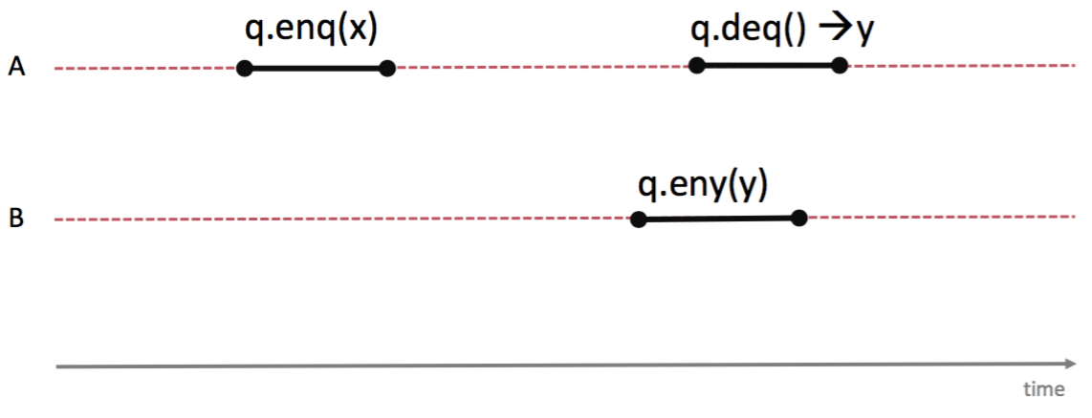 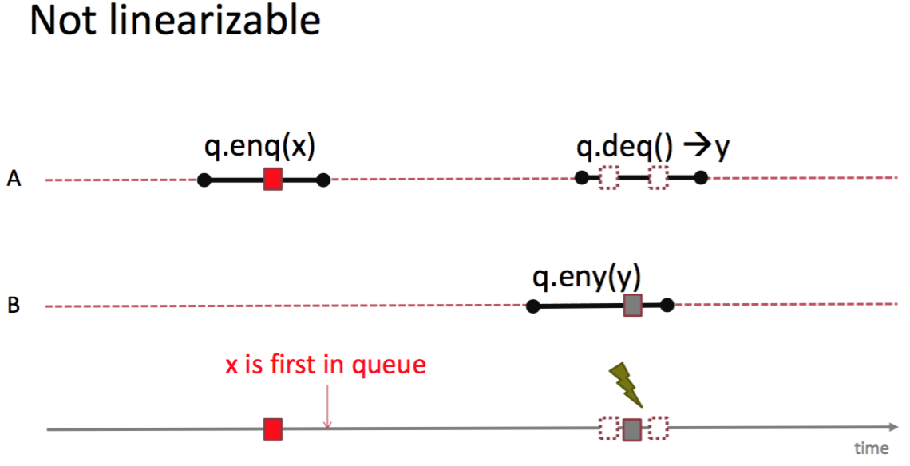 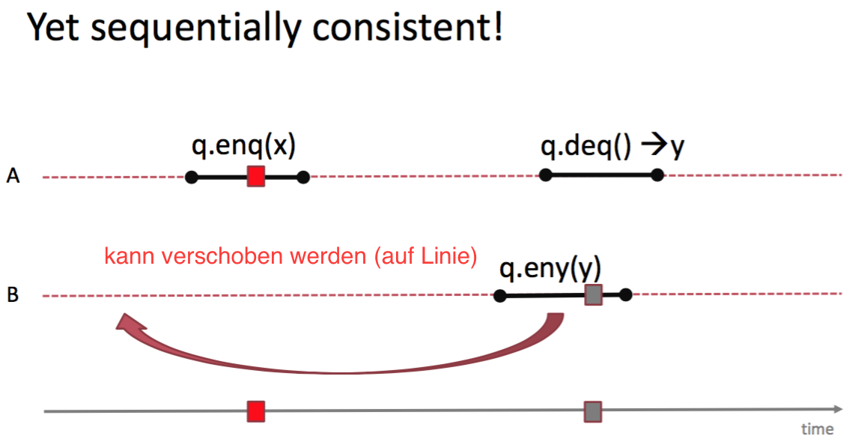

**Linearizability**

* Operation takes effect instantaneously between invocation and response
* Uses sequential specification, locality implies composablity
* Good for high level objects

**vs Sequential Consistency**

* Not composable
* Harder to work with
* No need to preserve real-time order
* Good way to think about hardware models

## Consensus

*Know that you cannot implement lock-free algorithms that require CAS with atomic registers.*

Consensus protocol: wait-free, consistent, valid

🡪 linearizability of consensus must be such that first thread’s decision is adopted for all threads

A class C solves n-thread consensus if there exists a consensus protocol using any number of objects and any number of atomic registers. **Consensus number of C:** max. n such that C solves n-thread consensus. *🡪 Atomic Registers have consensus number 1, Compare-And-Set has infinite consensus number.*

There is no wait-free implementation of n-thread consensus, n>1, from read-write registers*.* There is no lock-free implementation of a FIFO queue only with atomic registers

**🡪 wait-free FIFO queues, wait-free RMW operations and CAS cannot be implemented with atomic registers!**

# Transactional Memory

*Be able to explain the model of transactional memory. Be able to reproduce the semantics of transactional memory. Know serializability.*

*Be able to explain what a conflict is and how it is resolved (retry, abort). Be able to sketch the ideas of a very simple software transactional memory implementation.*

**Atomic blocks = transactions**

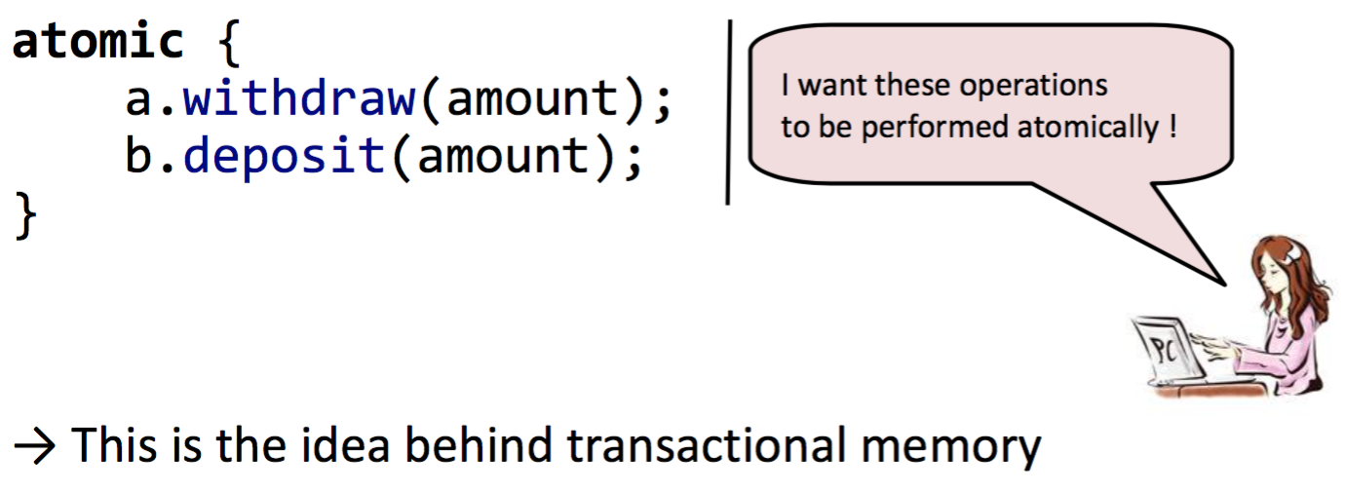 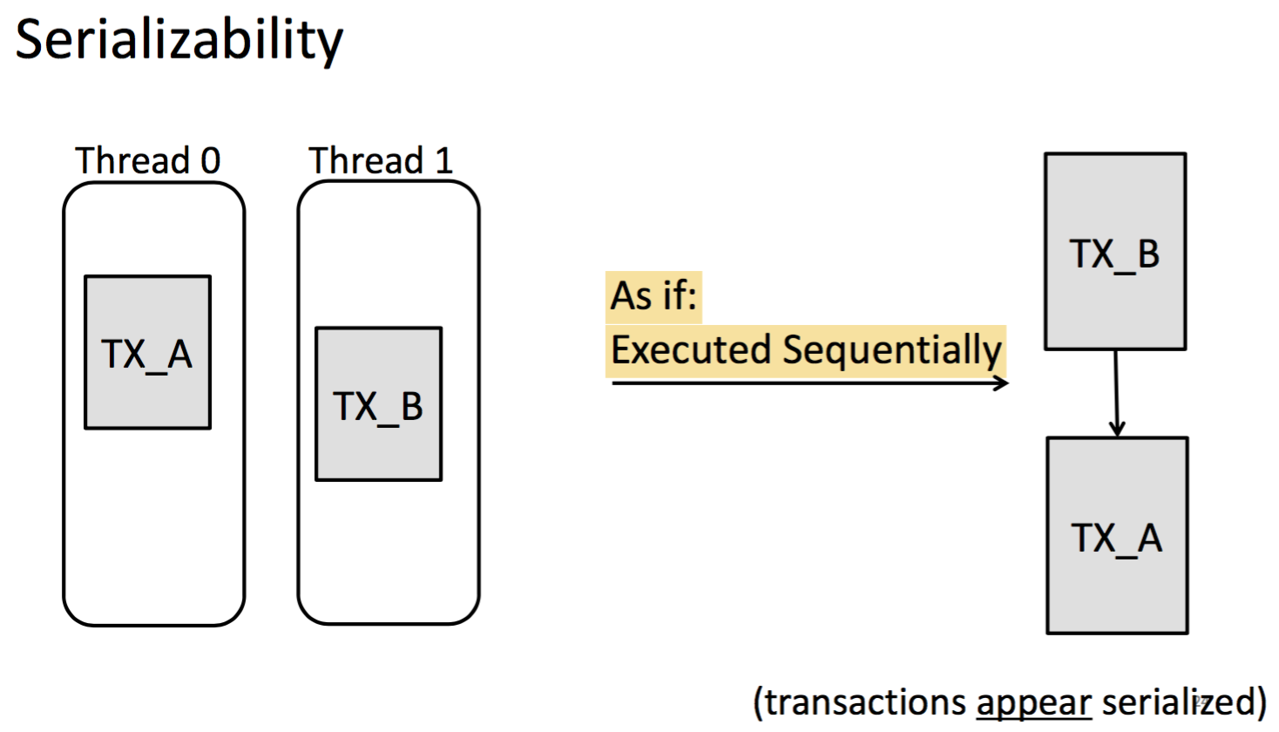

Programmer explicitly defines *atomic code sections* 🡪 Programmer is concerned with **what**: what operations should be atomic but not **how**: e.g., via locking, the how is left to the system (software, hardware or both)

TM is inspired by **ACID** Properties in Database transactions:

*Atomicity, Consistency, Isolation, Durability*

*Note: locks enforce atomicity via mutual exclusion, while transactions do not require mutual exclusion*

**TM benefits:** easier and less error-prone code; higher semantics (what vs how); composable; optimistic by design

**Implement TM:** Keep track of operations performed by each transaction: concurrency control, system ensures atomicity and isolation properties

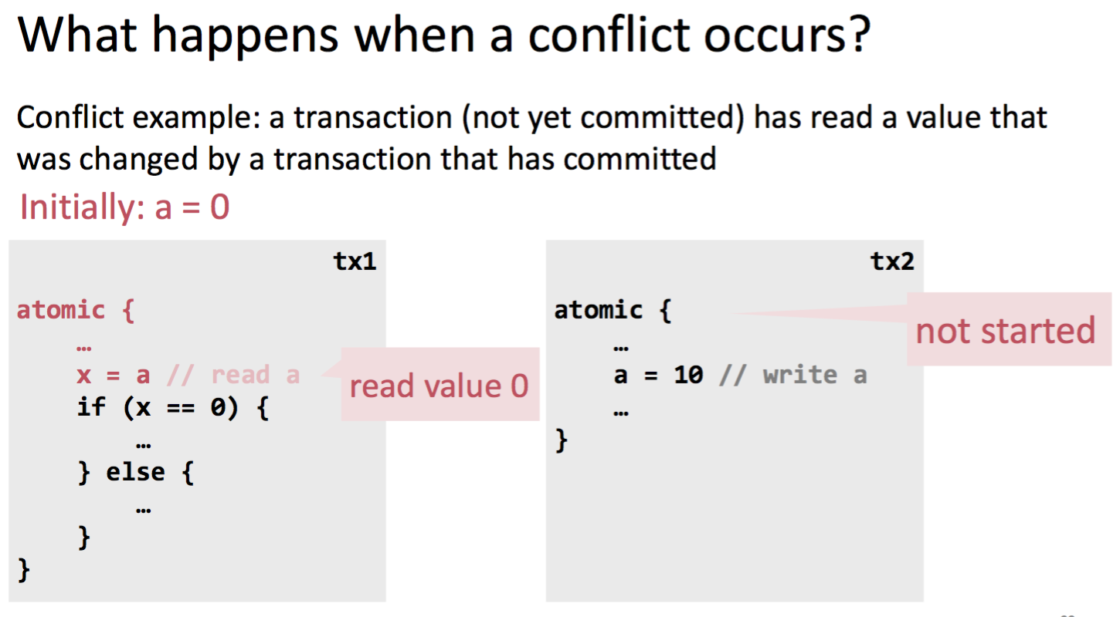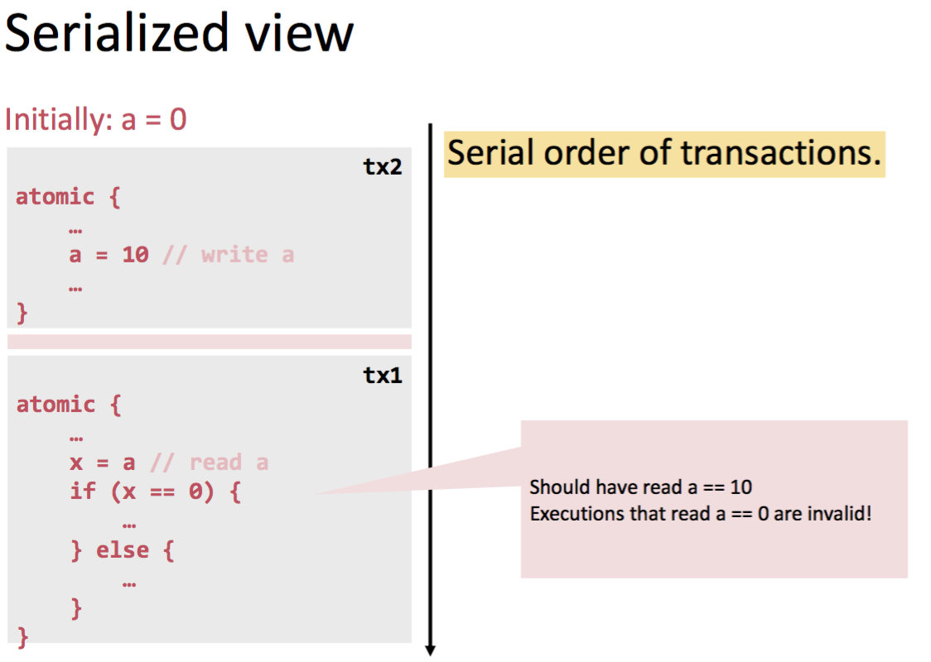

tx2 starts, tx2 updates a locally, tx2 commited – now changes visible to other transactions, tx1 commited

🡪 Transactions can be aborted

🡪 Issues like this are handled by the Concurrency control (CC) mechanism

**When a transaction aborts, it can be retried automatically or the user is notified 🡪 transactions are only completely executed, else they are retried or aborted**

🡪 The transactional memory system guarantees that **consistent** data will always be seen by a running transaction

🡪 see exercises dining philosophers implementation with TM

# Parallel Sorting

## Sequential Sort

*Know and understand the (best/worst case) runtimes of frequently used sorting algorithms. Understand the argument for required number of comparisons.*

Heapsort, Mergesort, Quicksort: O(n log n)

So maybe we can dream up another algorithm with a lower asymptotic complexity, such as O(n) or O(n log log n) 🡪 IMPOSSIBLE!

Algorithm must “find” the right answer among n! possible answers, starts “knowing nothing” and gains information with each comparison. Each comparison can, at best, eliminate half of the remaining possibilities 🡪 Can represent this process as a decision tree (binary tree) 🡪 Running any algorithm on any input will at best correspond to one root-to-leaf path in the decision tree 🡪 no algorithm can have worst-case running time better than the height 🡪 n log n

## Sorting Networks

*Understand and know the building blocks of networks. Know and understand what “oblivious” and “redundant” means in this context. Understand the recursive construction of sorting networks for insertion / selection sort. Equivalence of insertion/selection/bubble sort in parallel sorting networks.*

*Know the machine model PRAM.*

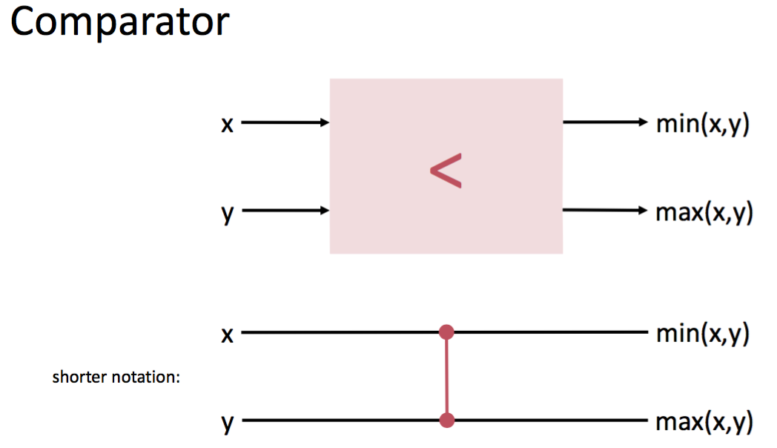 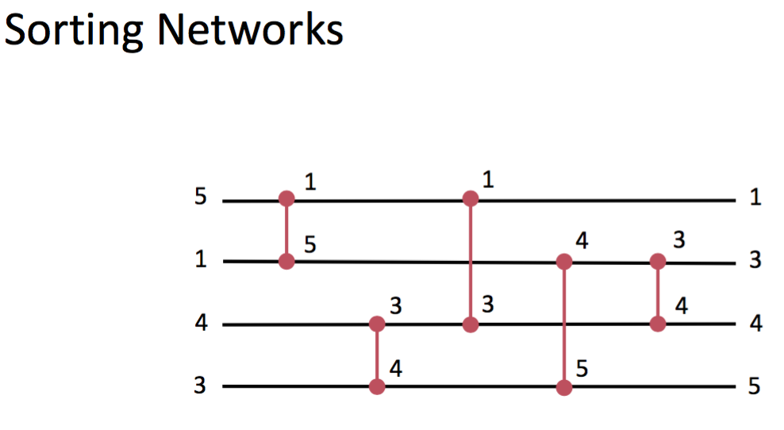

They are good for hardware implementations or massively parallel processors (e.g. FPGAs, GPUs)

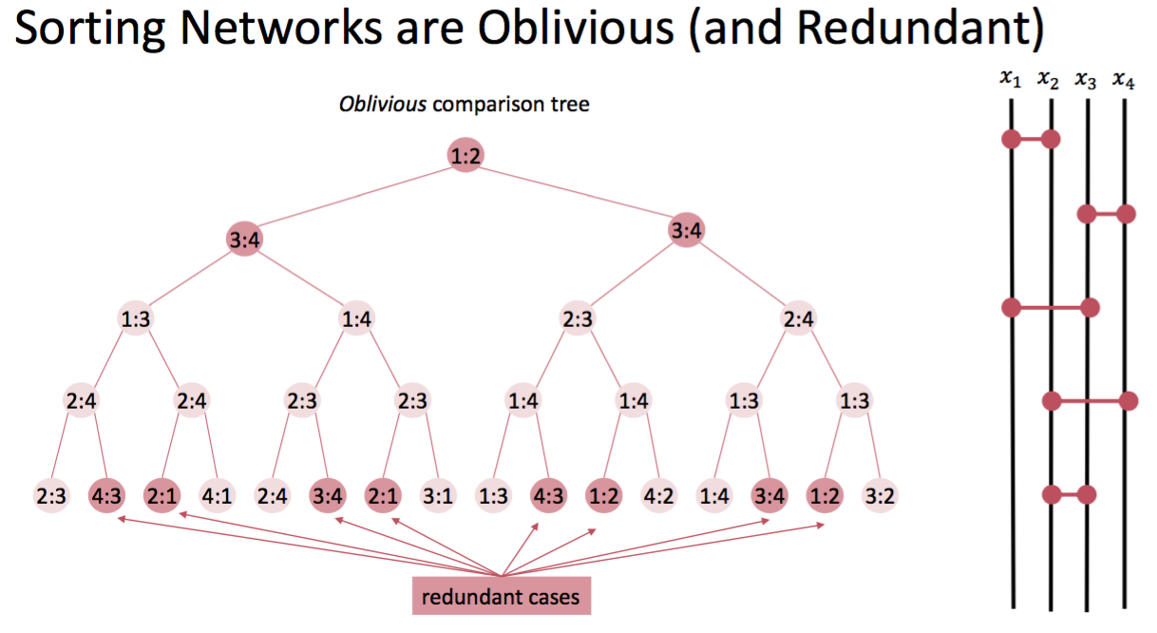

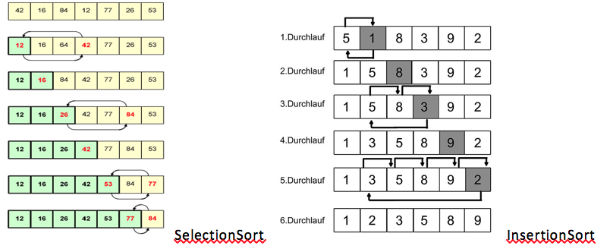

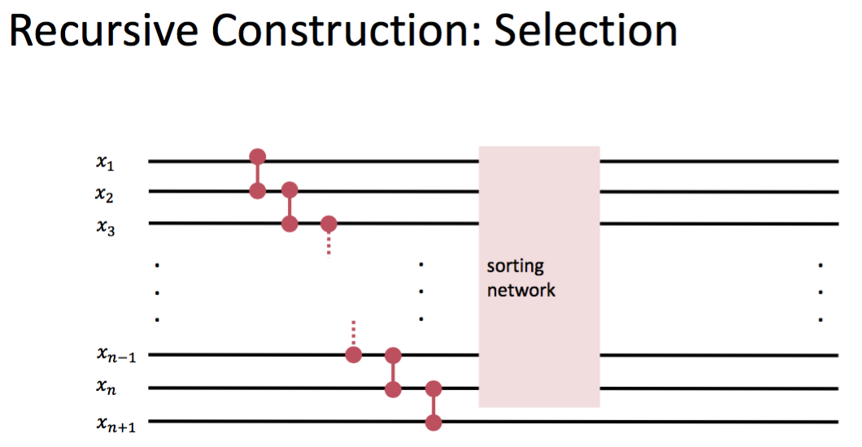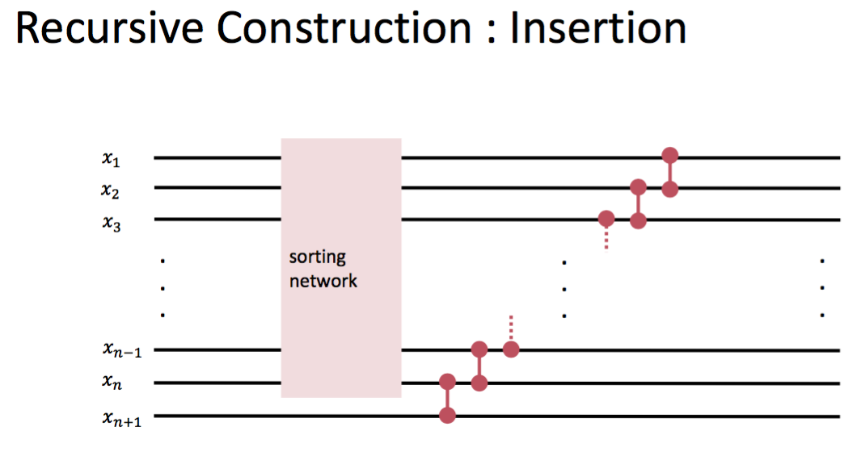

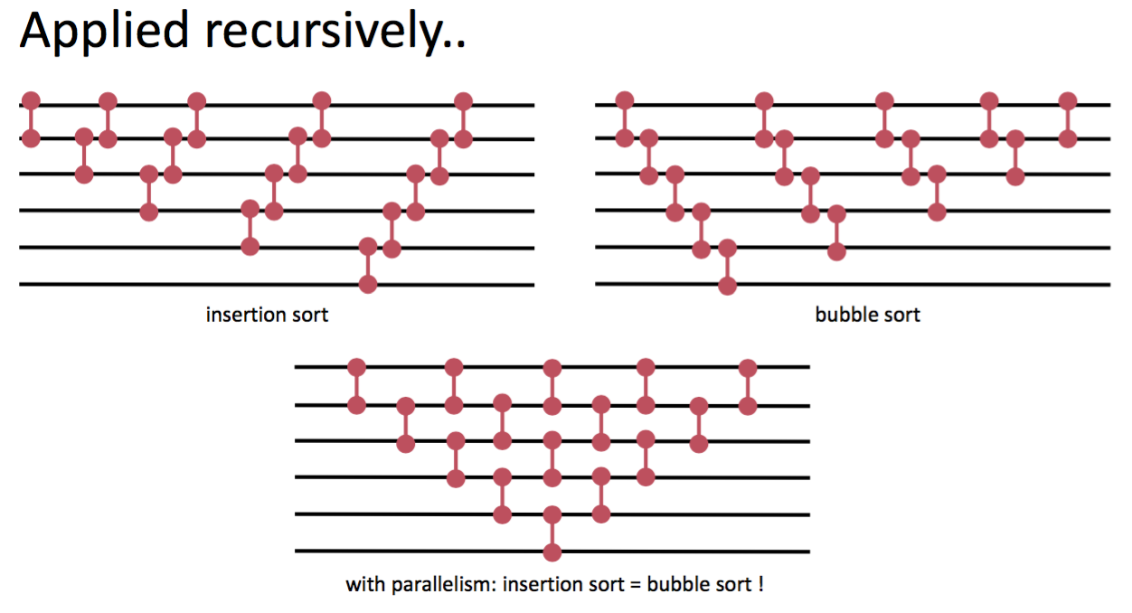

Machine Models -- **PRAM** : Parallel Random Access Machine

* Abstract machine for designing algorithms applicable for parallel computers
* Unbounded collection of RAM processors
* Each processor has unbounded registers
* Unbounded shared memory
* All processors can access all memory in unit time
* All communication via shared memory

## 0-1 Principle and Bitonic Sorting

*Know the 0-1 principle and how to apply it. No need to reproduce the proof.*

*Know and be able to reproduce what a Bitonic 0-1 sequence is, be able to reproduce recursive construction of a bitonic sorting network and how to translate this to a parallel algorithm.*

**0-1 Theorem:** If a network with 𝑛 input lines sorts all 2n sequences of 0s and 1s into non-decreasing order, it will sort any arbitrary sequence of 𝑛 numbers in nondecreasing order.

A bitonic sequence is defined as a list with **no more than one Local maximum and no more than one Local minimum.**

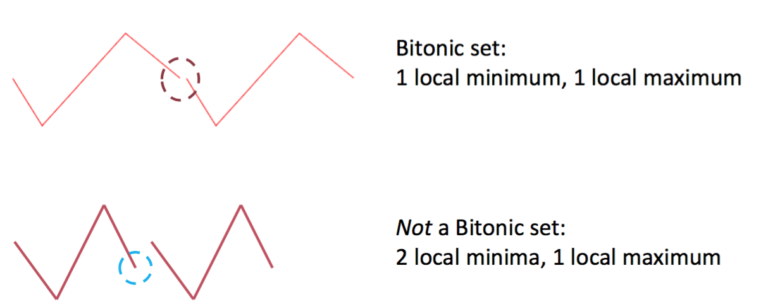 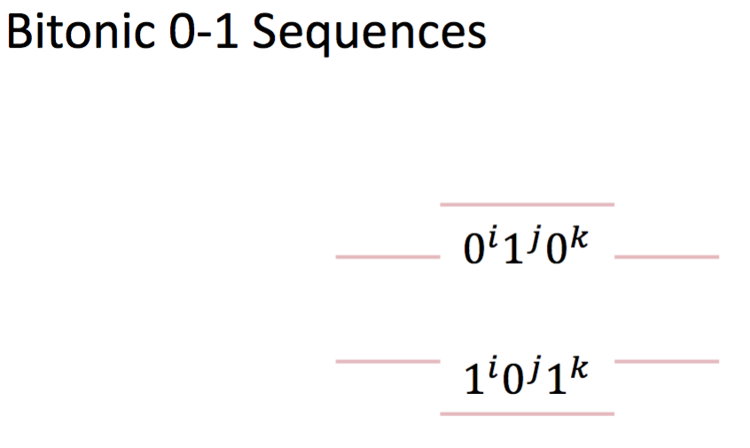

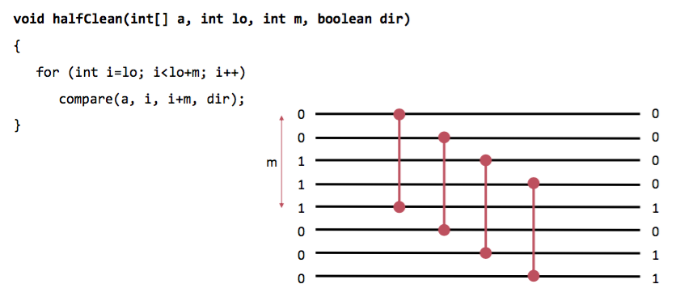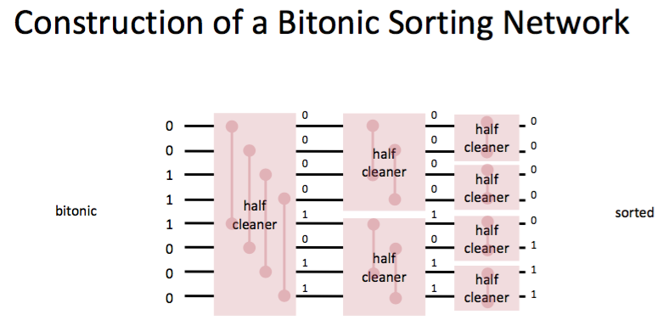

Bi-Merger If the input halves are sorted respectively, both output halves are bitonic.

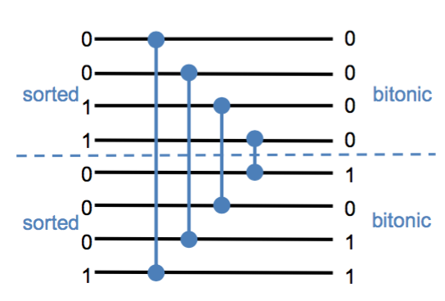 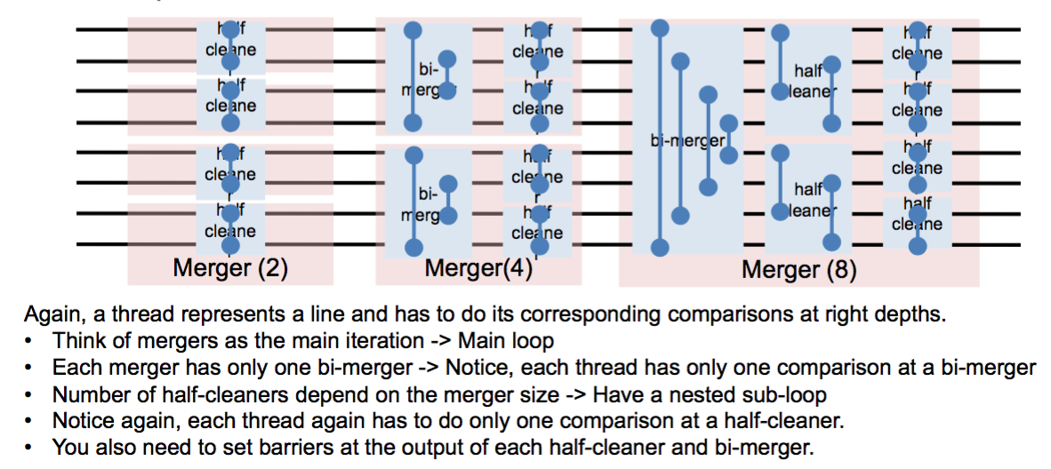

# Memory and Message Passing

## Memory

*Understand the issues of memory reorderings (Software and Hardware View), Know what a memory model is.*

**rule of thumb:** compiler and hardware allowed to make changes that do not affect the semantics of a sequentially executed program

*Software view:* compilers don’t guarantee that global ordering of memory accesses is provided

*Hardware view:* multiprocessors don’t enforce global ordering of all instructions for performance reasons

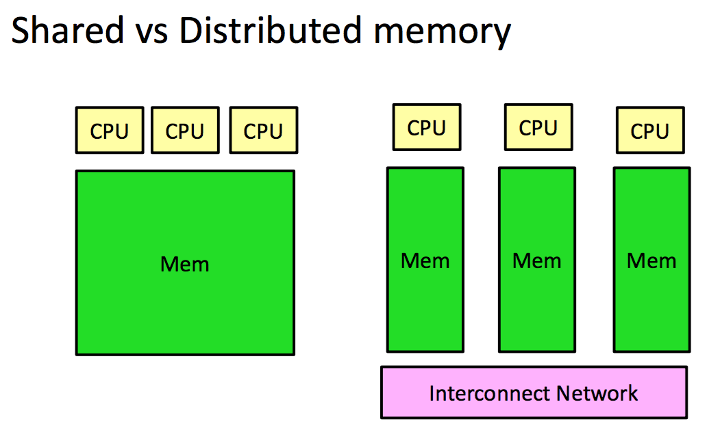

**Shared memory** architectures (e.g. multicores)

* Both message passing and sharing state is used
* Message passing can be slower than sharing data
* Easy to implement

**Distributed memory** architectures

* Sharing state is challenging and often inefficient
* almost exclusively use message passing
* Additional concerns: e.g., failures

**Memory models:**

behavior of threads interacting via shared memory depend on hardware, runtime system and programming language. A memory model (e.g. of a programming language like Java) *provides minimal guarantees for the effects of memory operations*

## Programming models

*Be able to reproduce the idea of the Actor Model and CSP. Know what is synchronous and asynchronous communication. No need to know programming languages like Erlang, Occam or go.*

🡪 Message Passing: **Isolated mutable state**

immutable: only read data, never written / mutable: read and write data

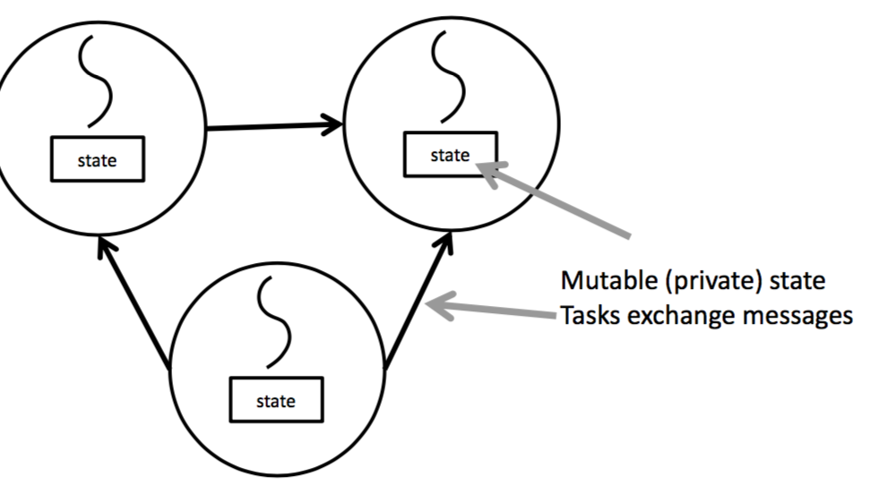 via message passing

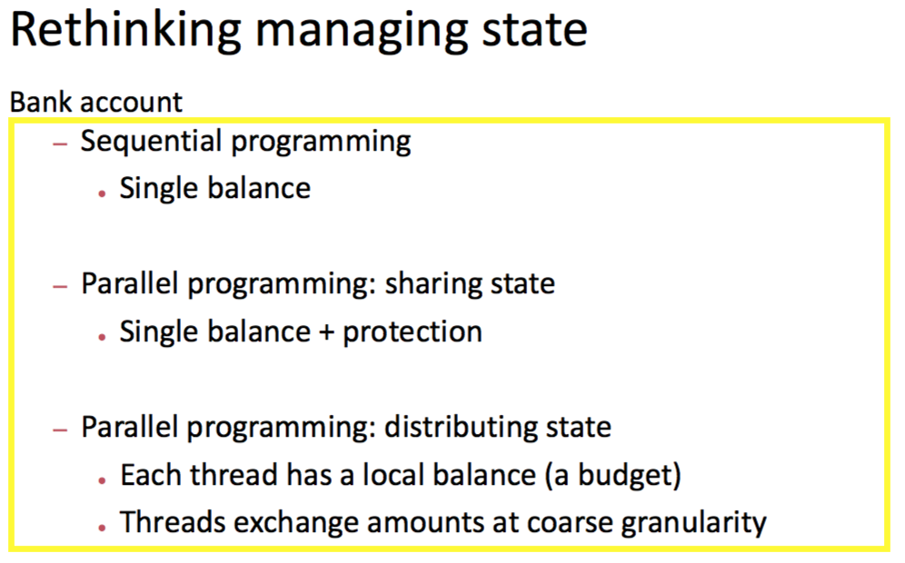🡪 shared state must be protected

**Synchronous messages:** *wait* until receiver is there, send message, in the same moment received

**vs Asynchronous messages:** sender *doesn’t wait* until receiver is there, place message into buffer for receiver to get, receive message later

**Actor model:**

Model of concurrent computation that threats actors (can be everything) as the elements / computational entities. In response to a message that it receives, an actor can: make local decisions, create more actors, send more messages (distributor), serialize messages (serializer), and determine how to respond to the next message received.

Actors may modify private state, but can **only affect each other through messages (asynchronous massage passing, no restriction on message arrival order),** avoiding the need for any locks.

Recipients of messages are identified by address 🡪 an actor can only communicate with actors whose addresses it has = **direct naming**.

🡪 Decoupling the sender from communications sent was a fundamental advance of the Actor model enabling asynchronous communication and control structures as patterns of passing messages

Implemented in Erlang, Scala, Ruby or frameworks as Akka (in Java).

**Communicating Sequential Processes:**

Operators seq (sequential) and par (parallel) for the hierarchical composition of processes. Synchronisation and Communication between parallel processes with Message Passing: Symbolic channels between sender and receiver 🡪 Read and write requires a rendevouz (**synchronous!**)

CSP includes an intermediary entity (port / channel) to address send destination: Process issuing send() specifies the port to which the message is sent, Process issuing receive() specifies a port number and waits for the first message that arrives at the port.

CSP was firstly implemented in Occam. Go was inspired by CSP.

## Message Passing Interface (MPI)

*Be able to shortly explain what MPI is.*

MPI = Standard Application Programming Interface 🡪 hides software/hardware details, portable, flexible, implemented as library

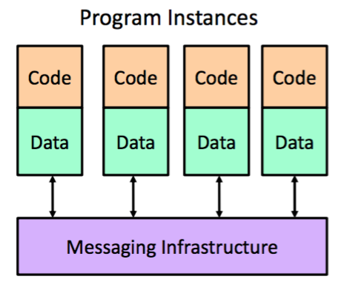🡪 DISTRIBUTED MEMORY

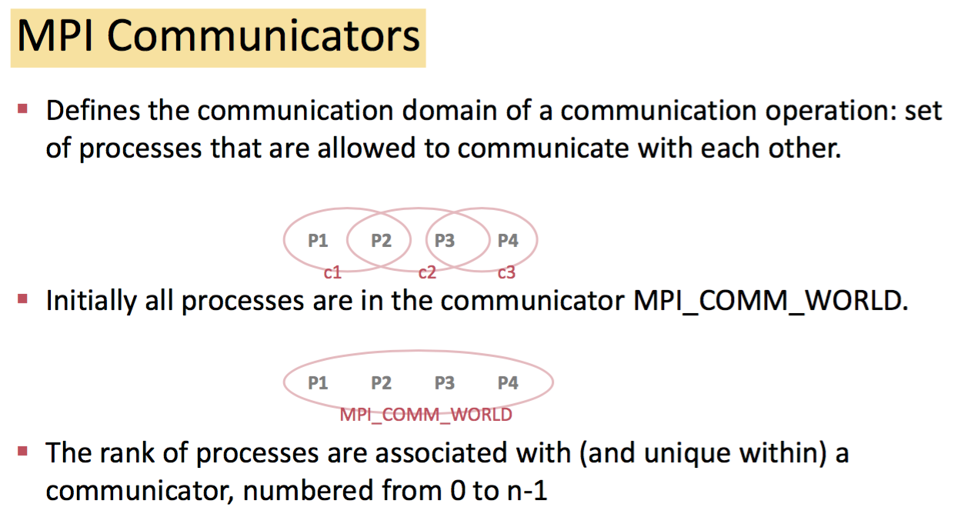 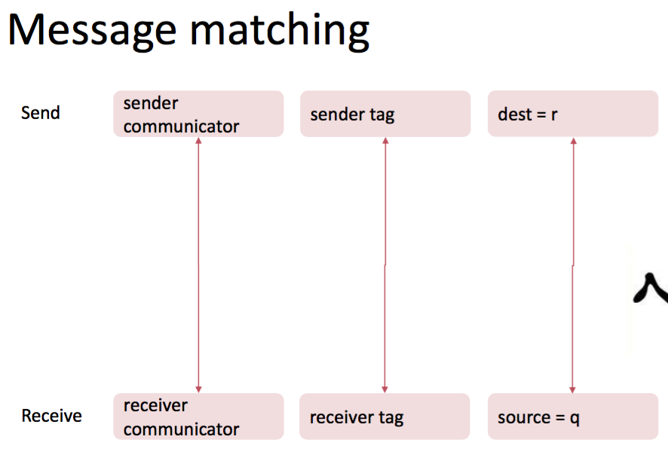

🡪 Communicating processes may need to send several messages between each other. Message tag: differentiate between different messages being sent.

🡪 A receiver can get a message without knowing the amount of data in the message,

the sender or the tag of the message.

**Synchronous message passing:**

*Synchronous send:* wait until complete message accepted by receiver before sending the message

*Synchronous receive:* wait until expected message arrives

🡪 Synchronous routines can perform two actions: **transfer data and synchronize processes**

**Asynchronous message passing:**

Send / Receive do not wait for actions to complete before returning 🡪 requires local storage for messages (implicit or explicit)

* **no synchronization**
* **allows local progress**

**synchronous / asynchronous: about communication between sender and receiver**

**blocking / nonblocking: about local handling of data to be sent / received**

Blocking: return after local actions are complete (MPI)

Non-blocking: return immediately